THE VIGILANTE
Volume 13 Issue 10 Editor: Nasty Newt SASS # 7365 July 2011

The Monthly Chronicle of the Robbers Roost Vigilantes

From The President
Those Lazy, Hazy, Crazy Days of Summer
Shooting twice a month has turned out to be one of the best ideas the RRV ever came up with. I wish I could take the credit, but it belongs to the Fundraiser Committee of Just George, Fullmoon, Kentucky Gal, Justin O Sheriff, Lady Jailer, Ball N Chain, and Buckhorn Bud. It has been a boon to the club’s bottom line, and equally important, it gives us the opportunity to shoot our cowboy guns twice a month without leaving the valley. In fact, everything the committee has touched has turned to gold, as their fund raising efforts have been highly successful by any measure. Good work, gang!
On July 2nd we had some early fireworks as 14 shooters turned out for another day in the sun. Justin O Sheriff came in first, and shot the match clean, followed by Bad Bascomb, Fast Legs, MC Ryder, and Buckhorn Bud, who was shooting Cap and Ball Gunfighter. Bud is good with those percussion revlovers. Goode Bascomb was the top lady gunhand on the day, and 7th overall.
On July 16th, 18 shooters made it out to the range, including Soledad, who blamed his late arrival on a rented mule. We let him shoot anyway. Bo Bean and his baby boy Jim Bean came over the mountain to shoot with us, and put on quite a show. When the last round had gone downrange, Bo had beaten Jim by 1.33 seconds for the six stages. That’ll teach him to mess with his old man. Justin O Sheriff finished third, 5.28 seconds off the pace. He also shot the match clean, and now has enough of MC Ryder’s hand made knives to outfit a squad of Al Qaeda cutthroats. Soledad and Venomous Doc rounded out the top 5. Goode Bascomb was the top lady and 12th overall.
All the scores for both July matches are available on our website.
Last month I said we weren’t shooting at RRV in August, but we are shooting the first Saturday, August 6th.
continued on page 2

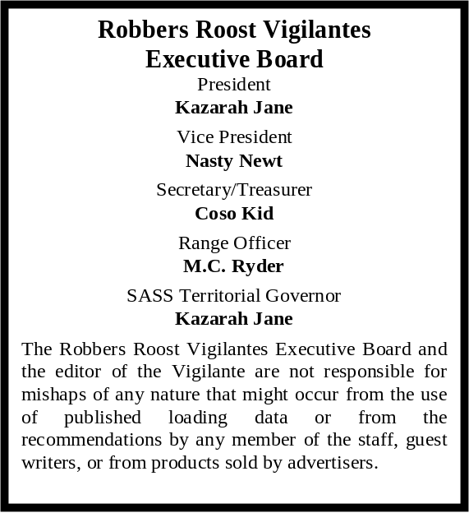

Just George, SASS Regulator

“Regulators are those folks who work above and beyond the call of duty for the benefit of SASS and their affiliated club(s). Their services are worth more than SASS or their club could ever pay. They personify the Cowboy Way and provide an excellent role model for others.”

That’s what SASS says it takes to be a Regulator. Sound like anybody we know? Sounds like Just George to me, and I was honored to present him with his Regulator badge at the July 16 RRV match (pictures on page 4). Here’s part of what I wrote in the nominating letter:

“Just George joined the RRV in 2006. Our club was started in 1998, and we had been having small anniversary shoots every year averaging 30 shooters, mostly club members.”

“In 2007 George volunteered his services as Match Director and went to work. Since then he has grown our anniversary match into a well-known four-day Annual Match called Defend the Roost that features nice awards, great food including pot lucks and a sit down banquet fit for a king (with Just George at the grille), popular vendors, and two dozen side matches including Wild Bunch and a night black powder shoot. Our matches are known for the fun factor, which is reflective of the personality of the Match Director. Defend the Roost was attended by 118 shooters in 2009, and was well-attended again in 2010.”

“In 2011 as in 2010, our club will host the SASS California State Black Powder Shootout at our spring annual, Resurrection at Robbers Roost. Hosting this SASS-sanctioned match is entirely due to Just George’s initiative and determination to make it happen.”

“George is singularly responsible for the mutually beneficial associations between our club and the Southern Nevada clubs.”

That sounds like a Regulator to me, and more importantly, to the Wild Bunch. NN

INSIDE THIS EDITION
1 From the President 3 RRV Match Schedule
1 Just George 3 Board of Directors
2 Bridgeport Invasion 3 Time to Renew
2 Upcoming Events 4 Photos
4 Work Party Update

Infornation
4 Where is “Why the West Was Won” ?

We’re sticking with the early schedule, of course, and we’ll be shooting by 8:00.

Note that the new shooter class will need to get underway by 6:30. If you know of a new shooter who wants to take the class, please call in advance:

Bad Bascomb, 760-375-7223
MC Ryder, 760-384-2321
UPCOMING EVENTS
Monthly shoots:
The Cajon Cowboys shoot on the: 2nd (club day) and 4th (open shoot) Saturdays of each month at the Gem Ranch in the Cajon Pass on old route 66. Contact Luke Warmwater at (909) 987-7017.
Five Dogs Creek Cowboys in Bakersfield shoot on the 1st weekend of each month. Call Dirt McFearson, (661) 805-3281.

High Desert Cowboys shoot in Acton on the 3rd Sunday. Contact Doc Silverhawks, (661) 948-2543.

Double R Bar Regulators, Lucerne Valley, shoot the 2nd Sunday. Call Five Jacks, (951) 347-0862.

Silver City Shooting Society shoots at Pahrump, NV, 4th Sunday. Call Philly Slim, (775) 764-0257. www.silvercityshootingsociety.com.

Lone Wolf Shooters, Pahrump, NV, shoot the 2nd weekend. Call Lash Latigo or Penny Pepperbox, (775) 727-4600 days, (775) 727-8790 evenings.

El Dorado Cowboys, Boulder City, NV, shoot the 1st weekend (Sat & Sun). Contact Charming at 702-565-3736, or Boxherder at 702-858-6396.
www.eldoradocowboys.com.

17th Chorro Valley Shootout, August 11 – 14, San Luis Obispo. Call Sinful, 805-286-1188. www.chorrovalleyregulators.org.

RRV Invades Bridgeport Vigilantes, Aug 19 – 20.
Continued from Page 1

Robbers Roost Vigilantes
Executive Board
President
Nasty Newt
Vice President
Bad Bascomb
Secretary
Goode Bascomb
Treasurer
Desert Willow
Territorial Governor
M. C. Ryder
Range Officer/Sgt. at Arms/Match Director
Just George
The Robbers Roost Vigilantes Executive Board and the editor of The Vigilante are not responsible for mishaps of any nature that might occur from the use of published loading data or from the recommendations by any member of the staff, guest writers, or from products sold by advertisers.
4th Annual RRV Invasion of the Bridgeport Vigilantes
August 19 – 20, 2011 : UPDATE

Check out these vital statistics: Elevation 6463 ft., average high and low temperature in August, 80 and 39, free dry camping on flat ground with mowed grass (Bodie Kid and Bee Blest’s yard), motels and several good restaurants available in town. Sounds pretty inviting, no? Well, you’ll get all that, and you’ll get to hang out with some really nice folks, shoot a great two-day cowboy match, and sidle up to a nice Friday pot luck and Saturday BBQ after the match up at Bridgeport.

Main stages both days, no side matches. Each day is a separate event. You can shoot both days, Friday only, or Saturday only. And should you decide to sign up for their annual, the Eastern Sierra Shootout, held on Sep 22 – 24, you can leave your RV in Bodie Kid’s yard and save yourself a round trip. For more information see their website at www.northernnevadacas.com or call Bodie Kid at 760-932-1139. Hope to see you there.

Business Card Advertising $24 for 12 Issues


BAD BASCOMB SASS #47,494
(aka MARI TODD)

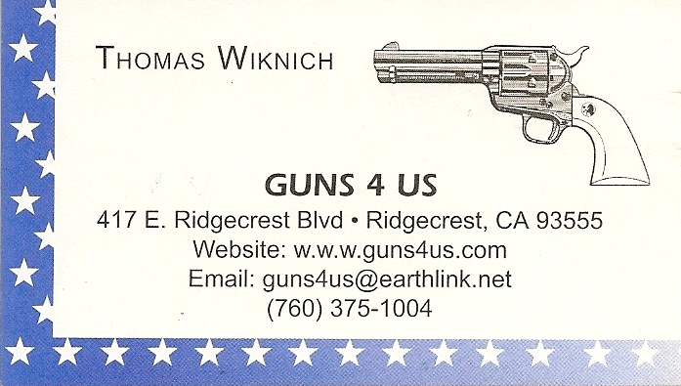

NAME BRANDS TO SURPLUS
QUALITY CLOTHING & EQUIPMENT
FOR TRAIL OR TRAVEL
(760) 375-7223

425 W RIDGECREST BLVD.  RIDGECREST, CA 93555


COLLINS GUNSMITHING
MODERN ANTIQUE REPLICA
ACTION JOBS BLUEING STOCK WORK
FOR ALL YOUR REPAIRS AND SERVICE
760-375-5703
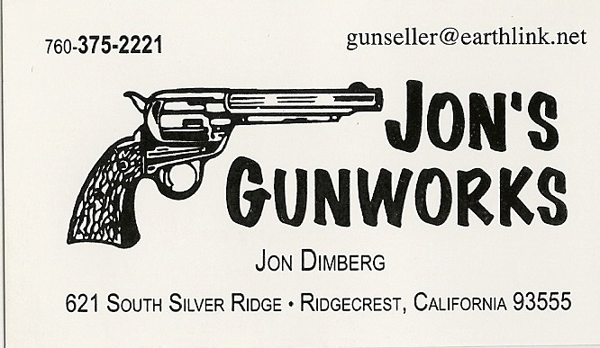

Schedule of Monthly Matches
RRV Match Dates:
NOTE: Information provided in the June Vigilante was wrong. We ARE SHOOTING August 6.
Signup: 7:00 Shooter Meeting: 7:45
New Shooter Class: 6:30

NO MATCH August 20 at RRV. Let’s go up and invade the Bridgeport Vigilantes. See article on page 2.

It’s Time to Renew Your RRV Membership

As always, if you renew your membership by the end of September, as a thank you, you’ll get a free shoot. No, not Defend the Roost ☺, but take your pick of a match in November or December. Dues (at left) are unchanged since ’98.
How to Join the Robbers Roost Vigilantes…

Come out to a RRV match, held the third Saturday of every month, or call Nasty Newt at 760-375-7618, or MC Ryder at 760-384-2321. Annual membership dues for the RRV are: single membership $25, member and spouse $30, family membership (including children under 18 living at home) $35. First time shooters will be able to take their FIRST (1) NEW SHOOTERS CLASS for $10, any subsequent new shooters class or RRV match shoot will be $10 members, $15 non members. Donations for shooting regular monthly RRV matches will be $10 members, $15 non-members. Memberships run from September 1 August 31. New memberships purchased after September will be prorated depending on the number of months remaining and the type of membership. RRV members are encouraged to become Single Action Shooting Society (SASS) members. Please call SASS at (505) 843-1320, or go to www. sassnet.com. SASS first year single initiation membership is $55, renewal for single membership is $45. As part of your SASS membership you will receive The Cowboy Chronicle (12 issues/year), registration of your alias, a SASS badge with your SASS number on it, a membership certificate and membership card, a SASS Marshall lapel pin, and SASS Shooters Handbook. SASS membership is not required for membership in RRV, or participation in RRV regular monthly matches. RRV encourages all shooters to join and support the NRA and the NRA Foundation, and Ridgecrest Gun Range Association. For further information visit our website at www.robbersroostvigilantes.com.

Board of Director Nominations Sought

It’s that time of year. In August we will elect a board of directors for the upcoming year. All members are eligible to run for a position on the board.

Yes, you can nominate yourself, and before you nominate someone else, make sure they are willing to serve if elected

Defend the Roost Work Parties: UPDATE

We’ve made good progress at the first two work parties, thanks to Just George, Justin O Sheriff, MC Ryder, Ballarat Bob, Nasty Newt, Buckhorn Bud, Badges, Harvey Mushman, Duelin’ Tom, and Bad Bascomb. In addition, Bad Bascomb has been repairing shotgun targets and Duelin’ Tom recently spent a morning grubbing brush for the parking lot expansion.

Here’s where we are as of 7/24/11:

Sat July 23. Install subfloor at new jail. Begin Install container anchors. POSTPONED, SCHEDULE TBD.

Sat July 30. Complete container anchor installation. Begin framing new jail.

FRI Aug 5th. Continue boardwalk repairs and jail framing.

FRI Aug 26th. Complete new jail. Begin painting and touch up of stages.

Sat Aug 27th. Continue painting and begin grounds clean up.

SUN Aug 28th. Complete painting and continue grounds clean up.

Sat Sep 10th. Final clean up.

Sat Oct 1. Posse 101 pre-shoot.
This is for the 8 or 10 members who make up Posse 101 and will not be shooting the main match, but working to put it on. We need spotters, brass pickers and a score keeper. That’s 5 or 6 folks for the entire day.

TUE Oct 4th. Tent set up and start move in.

WED Oct 5th. Complete move into the tent, kitchen and Yelping Coyote
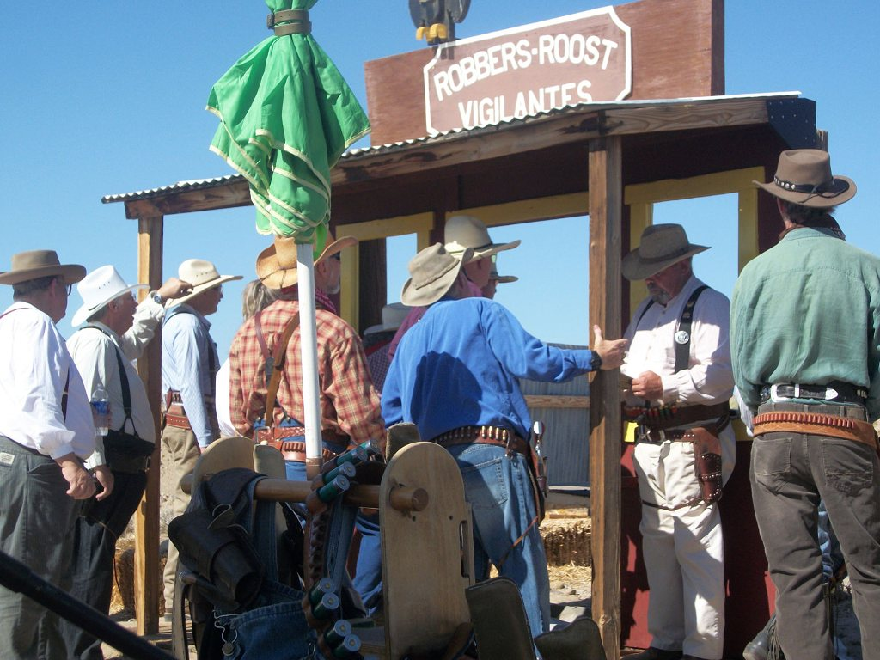
That’s enough fanfare. Back to work, Just George.

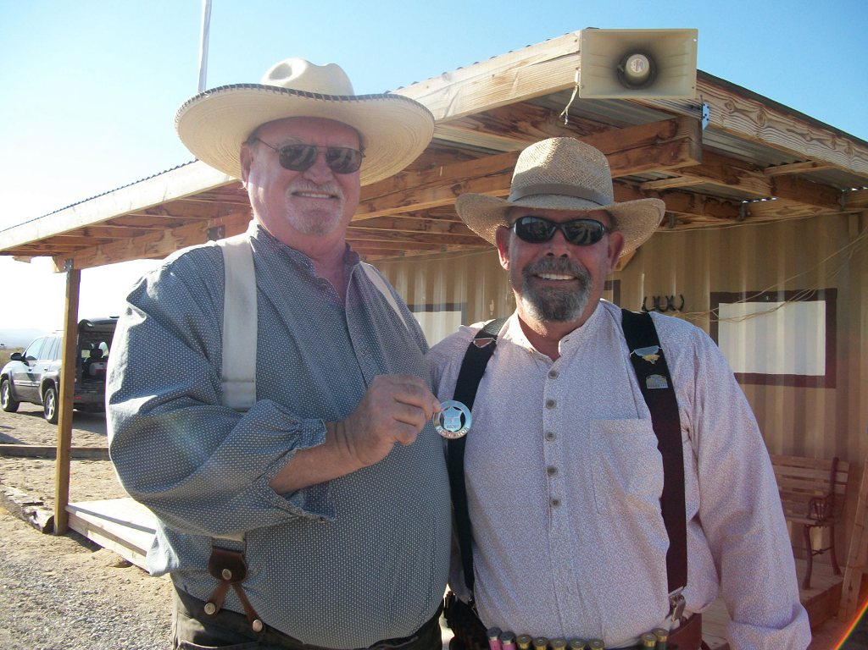

Nasty Newt, Just George, and The Badge.
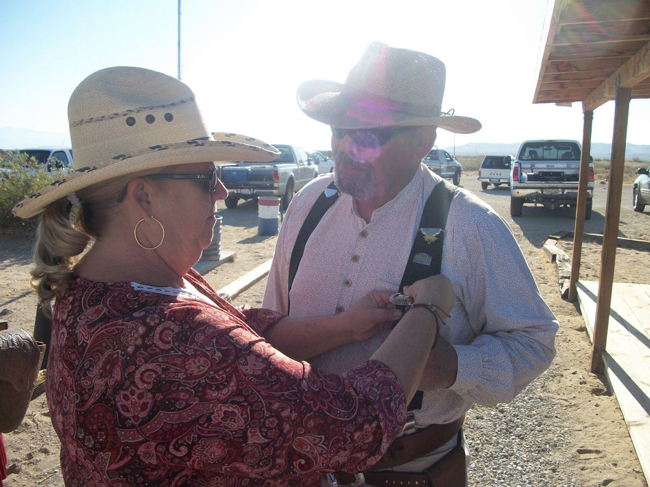

Fullmoon does the honors in a Cowboy Pinning Ceremony.

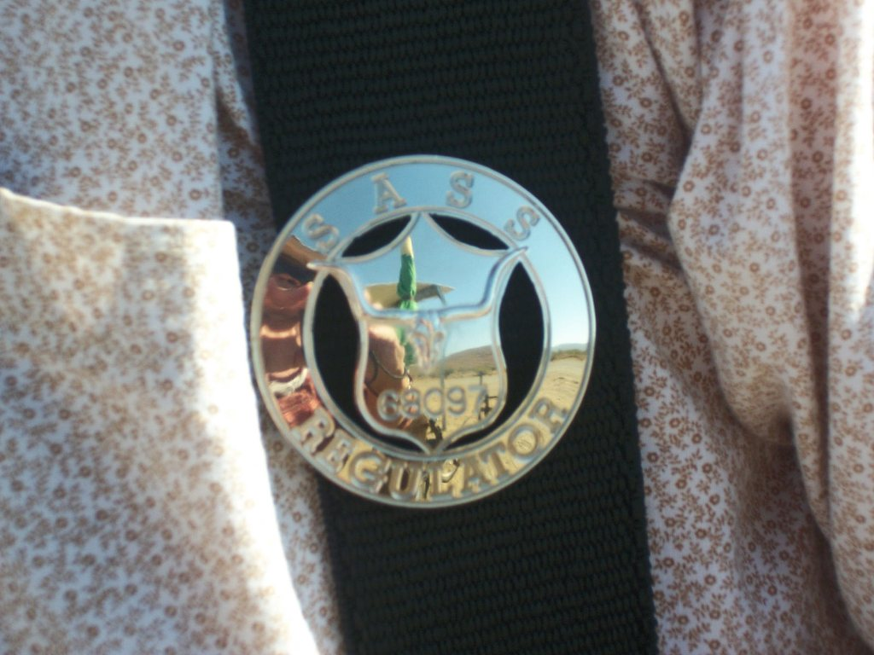

It looks like it belongs there.

