 THE VIGILANTE 
Volume 14 Issue 6 Editor: Nasty Newt SASS # 7365 February 2012

The Monthly Chronicle of the Robbers Roost Vigilantes

From The President
Two Great Matches in the Books
Darn near every year we have a spell of nice weather in February. 2012 has been no exception, leading some people to start digging in the flower bed and working on sprinkler systems. Those of us who have been around here a while know winter isn’t really over, and we just enjoy the balmy weather while it lasts.
What better place to do that than at the shooting range? The RRV went at it twice in February, with 21 shooters slinging lead on the 4th, and another 14 on the 18th.
The first Saturday match wound up being a birthday bash, as Ima Schofield, Goode Bascomb, and Crumville Kid were all properly insulted on the firing line with personalized stages, then wined and dined (OK, caked and teaed) in the cantina after the match. Justin O’Sheriff shot his way to the top of the pile, followed closely by Venomous Doc, Ozark Lawdog, Bad Bascomb, and Harvey Mushman. Kentucky Gal was top lady on the day and 11th overall. Sheriff, Lumpy Grits, and yours truly shot it clean.
The third Saturday match got off on the right foot with a great breakfast of biscuits and gravy, scrambled eggs, sausage, coffee, and orange juice, prepared on the spot and served up by Just George and Kentucky Gal. For the shooting part, Cowboy Earl had suggested we use his shotgun knockdown/clay pigeon tosser and his stationary clay pigeon holder, which we did. I had already planned a stage that included a provided Handi-Rifle and one cartridge for an optional bonus shot, not to mention a “long range” Nevada Sweep. So, by the time the dust had settled, we had probably managed to make just about everybody happy—there was bound to be something that you liked out there.
As is his habit, Justin O’ Sheriff ran away from the field, followed by Harvey Mushman, Bad Bascomb, Cowboy Earl, and top lady Kentucky Gal. Speaking of habits, the Sheriff also shot the match clean. All of the scores from both matches are on our web site.
continued on page 2

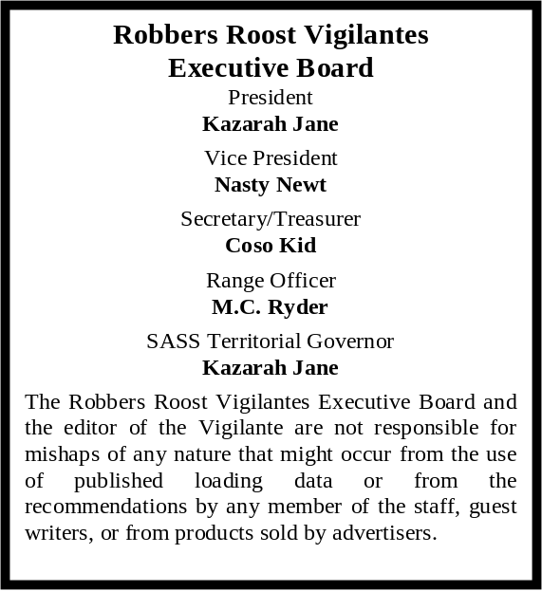

Death Valley National Park
and Defend the Roost
by
Nasty Newt, SASS #7365

Now that the headline has gotten your attention and you’re reading this, you may be wondering what Death Valley and our annual match have to do with one another. I’m the first to admit that my mind works in mysterious ways, but I do believe they may have something in common.

A lot of us take it for granted that Death Valley is right next door. To some who live here, it’s no big deal. I know people who have lived here for years who haven’t laid eyes on Scotty’s Castle, or walked around the visitor’s center at Furnace Creek. They might take Highway 190 to Nevada, but they don’t stop for a cold drink at Stovepipe Wells, take a walk up the hill to the Zabriskie Point overlook, or drive a few miles out of their way to see Badwater. Never mind that people come from all over the world to visit Death Valley. To them, it’s a uniquely wondrous place. To us, it’s just another big chunk of desert. Yawn.

Over the years, Defend the Roost has drawn shooters from Nevada, Arizona, Utah, Idaho, Colorado, Minnesota—well, you get it. The word is out about what we do, and the way we do it, and shooters from all over make a considerable investment of time, energy, and money to come here and enjoy the experience. To them, it’s a fun match and a great bang for their hard-earned buck, and well worth the trip. However, as I write this, only eleven RRV members are signed up for Defend the Roost, only six of whom reside in the Indian Wells Valley.

I know not everyone can attend the match, but don’t take Defend the Roost for granted. It’s a really good event at a really good range that most clubs would kill for. Walk up to Zabriskie Point sometime, and get signed up for Defend the Roost. You won’t regret it.

INSIDE THIS EDITION
1 From the President 3 RRV Match Schedule
1 Defend the Roost 3 Range Needs Sprucing Up
2 IAC Model 93/97
2 Upcoming Events

Infornation
4 Where is “Why the West Was Won” ?

The next matches are March 3rd and 17th, with sign-ups at about 8:00, and the shooter meeting around 8:45.

There will not be a new shooter class on the 3rd. Anyone wishing to take the new shooter class on the 17th should be at the range by 7:30. As always, we request advance notice if someone wants to take the class so we can be prepared.

Note: The third Saturday match will feature special St. Patrick’s Day stages by MC Ryder. Don’t miss it!
UPCOMING EVENTS
Monthly shoots:
The Cajon Cowboys shoot on the: 2nd (club day) and 4th (open shoot) Saturdays of each month at the Gem Ranch in the Cajon Pass on old route 66. Contact Luke Warmwater at (909) 987-7017.
Five Dogs Creek Cowboys in Bakersfield shoot on the 1st weekend of each month. Call Dirt McFearson, (661) 805-3281.

High Desert Cowboys shoot in Acton on the 3rd Sunday. Contact Doc Silverhawks, (661) 948-2543.

Double R Bar Regulators, Lucerne Valley, shoot the 2nd Sunday. Call Five Jacks, (951) 347-0862.

Silver City Shooting Society has suspended operations until further notice.

Lone Wolf Shooters, Pahrump, NV, shoot the 2^{nd,} 4th and 5th Sunday. Call Lash Latigo or Penny Pepperbox, (775) 727-4600 days, (775) 727-8790 evenings.

El Dorado Cowboys, Boulder City, NV, shoot the 1st weekend (Sat & Sun). Contact Charming at 702-565-3736, or Boxherder at 702-858-6396.
www.eldoradocowboys.com.

Nevada Rangers host Stampede, April 5 - 7 2012, Clark County Shooting Complex, Las Vegas. For info, www.nevadarangers.com.

Continued from Page 1

Robbers Roost Vigilantes
Executive Board
President
Nasty Newt
Vice President
Bad Bascomb
Secretary
Goode Bascomb
Treasurer
Desert Willow
Territorial Governor
M. C. Ryder
Range Officer/Sgt. at Arms/Match Director
Just George
The Robbers Roost Vigilantes Executive Board and the editor of The Vigilante are not responsible for mishaps of any nature that might occur from the use of published loading data or from the recommendations by any member of the staff, guest writers, or from products sold by advertisers.
The IAC 93/97 is Approved for SASS Wild Bunch

After several years, SASS has decided that this shotgun, a Chinese made clone of the Winchester Model 97 which includes the unfortunate addition of a Model 93-style cut-out on the ejection port, can be used in SASS sanctioned Wild Bunch matches. The gun remains on the banned list for Cowboy Action Shooting on the grounds that the enlarged port gives a competitive advantage when single loading, which is the way most shooters use a 97. This decision is explained by the fact that in Wild Bunch, the shells are loaded in the tubular magazine at the loading table, so the competitive advantage doesn’t come into play.

These are good shotguns, built like a tank and very reliable. There are currently none being imported, and unless SASS comes to its senses and allows it for CAS, there probably won’t be any more. I don’t know anybody who believes in the “competitive advantage” associated with the port cut-out, but then, I don’t know anybody in the SASS hierarchy.

Meanwhile, if you have one, you can use it in RRV monthly matches, and you can also use it in our “Professionals” side match at Defend the Roost in May. However, since DTR is a SASS-sanctioned event, you will not be allowed to use it in the 10 stage main match or other side matches.

Business Card Advertising $24 for 12 Issues


BAD BASCOMB SASS #47,494
(aka MARI TODD)

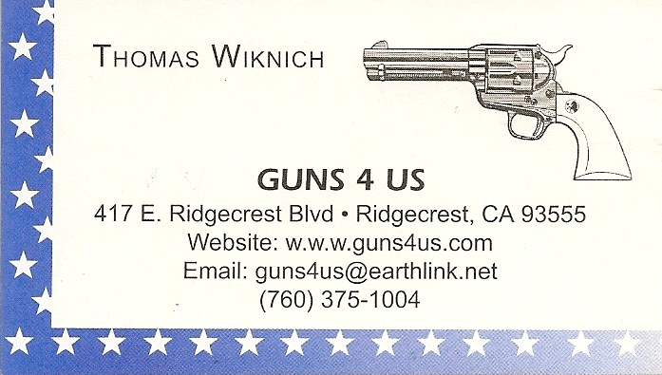

NAME BRANDS TO SURPLUS
QUALITY CLOTHING & EQUIPMENT
FOR TRAIL OR TRAVEL
(760) 375-7223

425 W RIDGECREST BLVD.  RIDGECREST, CA 93555


COLLINS GUNSMITHING
MODERN ANTIQUE REPLICA
ACTION JOBS BLUEING STOCK WORK
FOR ALL YOUR REPAIRS AND SERVICE
760-375-5703
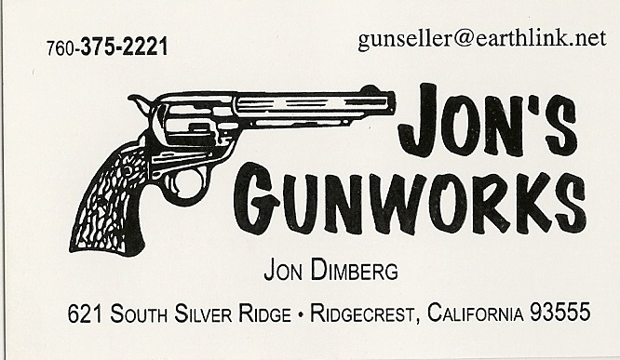

How to Join the Robbers Roost Vigilantes…

Come out to a RRV match, held the first and third Saturdays of every month, or call Nasty Newt at 760-375-7618, or MC Ryder at 760-384-2321, or mail it in. Our membership application is here RRV Membership Application Annual membership dues for the RRV are: single membership $25, member and spouse $30, family membership (including children under 18 living at home) $35. First time shooters will be able to take their FIRST (1) NEW SHOOTERS CLASS for $10, any subsequent new shooters class or RRV match shoot will be $10 members, $15 non members. Donations for shooting regular monthly RRV matches will be $10 members, $15 non-members. Memberships run from September 1 - August 31. New memberships purchased after September will be prorated depending on the number of months remaining and the type of membership. RRV members are encouraged to become Single Action Shooting Society (SASS) members. Please call SASS at (505) 843-1320, or go to www. sassnet.com. SASS first year single initiation membership is $55, renewal for single membership is $45. As part of your SASS membership you will receive The Cowboy Chronicle (12 issues/year), registration of your alias, a SASS badge with your SASS number on it, a membership certificate and membership card, a SASS Marshall lapel pin, and SASS Shooters Handbook. SASS membership is not required for membership in RRV, or participation in RRV regular monthly matches. RRV encourages all shooters to join and support the NRA and the NRA Foundation, and Ridgecrest Gun Range Association. For further information visit our website at www.robbersroostvigilantes.com.

Schedule of Monthly Matches
RRV Match Dates:

March 3 2012. Sign-up ~ 8:00, meeting ~ 8:45. No breakfast, no new shooter class.

March 17 2012. Breakfast TBA. New shooter class at 7:30. Sign-up ~ 8:00, meeting ~ 8:45.

The Range Needs Some Touching Up
Next Work Party is Saturday, February 25th

You might be thinking that all we ever ask you to do is come out and work, but not really. We also invite you out for some really fun shooting matches--twice a month, these days. Anyhow, on the 11th Justin O’ Sheriff, Kentucky Gal, Just George, MC Ryder, Bad Bascomb, Harvey Mushman and Buckhorn Bud were at it again building the jail. Cowboy Earl is gearing up to make a truckload of targets and stands.

Now it needs paint, and some other areas of the range need sprucing up, and if we have enough people we will start on a bullet proof wall to make another bay. If you can come out, there will definitely be something for you to do. Thanks.

