THE VIGILANTE 
Volume 15 Issue 6 Editor: Nasty Newt SASS # 7365 February 2013

The Monthly Chronicle of the Robbers Roost Vigilantes

From The President
Slings, Arrows, Outrageous Fortune
And the Chicago Mob (1930’s Style)
The Vigilantes must be living right, or maybe somebody we know is living right. Anyway we managed to catch perfect shooting weather for both matches in January, and did it again in February. Those of us who’ve been around here for a while know it isn’t unusual to have a faux early spring, but it’s just as likely to be butt-freezing cold, so we’ve been lucky, and if you didn’t come out and shoot, you missed out.
Ten shooters came out for the first Saturday match featuring six great stages, including one by Buckhorn Bud that included a loaner derringer. Bad Bascomb and Goode Bascomb opted to use their own derringer, “Old Betsy,” which of course promptly failed to fire. Derringer troubles notwithstanding, he finished first overall, and she was top lady and sixth overall. MC Ryder, Harvey Mushman, Rusty Dover and Ozark Lawdog rounded out the top five. Nobody shot the match clean.
Thirteen shooters shot the St. Valentine’s Day tribute on the third Saturday. We had props galore, including a 1911 at the St. Valentine’s Day Massacre, a candy-gram for Mongo, and an errant arrow fired by a bumbling Cupid. Not to mention that we ordered a dozen mail-order brides, and got a partial shipment of one. That got ugly very quickly—the situation, not the bride.
Bad Bascomb, Cowboy Earl, MC Ryder, Harvey Mushman, and Venomous Doc finished first – fifth respectively, and Cowboy Earl and Harvey Mushman did it shooting cap and ball pistols! Goode Bascomb, perennial top lady, was seventh overall, and yours truly managed to clean the match for the first time in a long while.
It was good to see Rusty Dover and Duelin’ Tom out at the range this month. Don’t be strangers, fellas.
continued on page 2

SHOOTOUT AT HIGH NOON
By Nasty Newt
SASS # 7365
Once or twice month, we all head out into the desert and get into gunfights. Even though we normally have to deal with ten to fifteen desperadoes at a time, they just stand there looking stupid, and usually don’t shoot back, so even if we miss with a shot or two, it isn’t too tough to win the fight.

The game of Cowboy Action Shooting is based on that version of the old west we’ve been watching all of our lives on television and at the movies. Since our frame of reference is largely fantasy, it makes perfect sense that our game is, too, and I prefer it that way. I like it when the bad guys stand still and don’t shoot back, and let the good guy, namely me, win.

But what was it like, really? Was it really Gary Cooper, alone, vs. Frank Miller and his gang of no-accounts while the trembling citizens huddled in fear in their stores and blacksmith shops? Well, as Gary Cooper might have put it, “Nope.” The notion of the cowardly townie is a classic Hollywood myth. They would have us believe that only a handful of individuals in the old west had the steel to pick up a firearm and stand up for what was right. Lawmen and wandering white knight gunfighters like Shane or Cheyenne would step up and fight it out with the lawless element, but just about everybody else—farmers, cooks, merchants, ranchers,
continued on page 2

INSIDE THIS EDITION
1 From the President 3 Defend the Roost 2013
1 Shootout at High Noon 3 RRV Match Schedule
2 Upcoming Events

2 Upcoming Events

Information
4 Where is “Why the West Was Won” ?

UPCOMING EVENTS
Monthly shoots:
The Cajon Cowboys shoot on the: 2nd (club day) and 4th (open shoot) Saturdays of each month at the Gem Ranch in the Cajon Pass on old route 66. Contact Luke Warmwater at (909) 987-7017.
Five Dogs Creek Cowboys in Bakersfield shoot on the 1st weekend of each month. Call Dirt McFearson, (661) 805-3281.

High Desert Cowboys shoot in Acton on the 3rd Sunday. Contact Doc Silverhawks, (661) 948-2543.

Double R Bar Regulators, Lucerne Valley, shoot the 2nd Sunday. Call Five Jacks, (951) 347-0862.

Lone Wolf Shooters, Pahrump, NV, shoot the 4th and 5th Sunday. Call Lash Latigo or Penny Pepperbox, (775) 727-4600 days, (775) 727-8790 evenings.

El Dorado Cowboys, Boulder City, NV, shoot the 1st weekend (Sat & Sun). Contact Charming at 702-565-3736, or Boxherder at 702-858-6396.
www.eldoradocowboys.com.

Bridgeport Vigilantes, Bridgeport, CA. Ben Maverick has announced that they will resume shooting in May. Since the Western Regional will be in August this year, plans for the RRV’s Bridgeport invasion are TBA.
Continued from page 1

Regarding the opening paragraph of this column, I just checked the weather and we’re looking at rain and wind Tuesday, and snow showers Wednesday. Yep, we’ve been mighty lucky. ☺

In March we’re shooting on the 2nd and the 16th. Sign up at 8:00, meeting at 8:45, and new shooter class at 7:30. We’d like to know in advance if a new shooter is coming out. See ya out there!

Robbers Roost Vigilantes
Executive Board
President
Nasty Newt
Vice President
Bad Bascomb
Secretary
Goode Bascomb
Treasurer
Desert Willow
Territorial Governor
M. C. Ryder
Range Officer/Sgt. at Arms/Match Director
Just George
The Robbers Roost Vigilantes Executive Board and the editor of The Vigilante are not responsible for mishaps of any nature that might occur from the use of published loading data or from the recommendations by any member of the staff, guest writers, or from products sold by advertisers.

Shootout Continued from page 1

newspaper editors, tradesmen, laborers, etc., mostly stood around with their knees knocking. Why did the film makers force-feed us this image of the west? Probably because it gave the hero the opportunity to rise to the occasion and save everybody, which is, after all, what heroes are for.

However, as Louis L ’Amour pointed out many years ago, such was simply not the case. The men and women who settled the west after the Civil War were a hardy bunch. They not only knew how to take care of themselves, they were more than willing to do it. Many of those general stores and blacksmith shops were owned and operated by men who were veterans, both North and South, of the “recent unpleasantness.” The women were made of equally stern stuff. They had raised the children, plowed the fields, put up the crops, and slaughtered the pigs while their men were at war. According to L ‘Amour, guns were a part of these folks’ everyday lives. They owned them, they knew how to use them, and they weren’t likely to jump behind the counter and hide when trouble rode into town.

History proves L ‘Amour was right. Although there no doubt are countless lesser known examples, we’re very familiar with two. In 1876, when the James and Younger gang ventured north out of Missouri and rode up
continued on page 4

Business Card Advertising


BAD BASCOMB SASS #47,494
(aka MARI TODD)

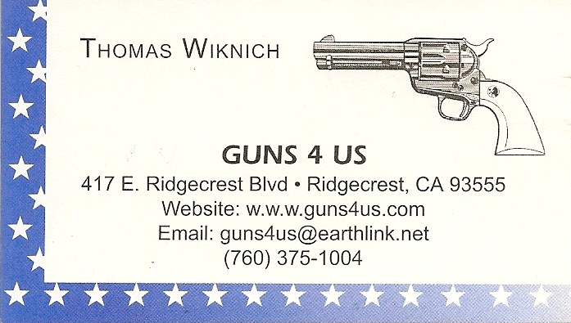

NAME BRANDS TO SURPLUS
QUALITY CLOTHING & EQUIPMENT
FOR TRAIL OR TRAVEL
(760) 375-7223

425 W RIDGECREST BLVD.  RIDGECREST, CA 93555

Defend the Roost 2013
May 16, 17, 18, and 19

Yep, it will be here before you know it. Application, Information, and Liability Release form are all on our web site at www.robbersroostvigliantes.com. Get it filled out and send it to our Match Director, Just George, at the address shown on the application. You can pay later if you want to, but get your name on the Who’s Comin’ list, like, RIGHT NOW!

COLLINS GUNSMITHING
MODERN ANTIQUE REPLICA
ACTION JOBS BLUEING STOCK WORK
FOR ALL YOUR REPAIRS AND SERVICE
760-375-5703

Schedule of Monthly Matches
RRV Match Dates:
March 2, 2013.
March 16, 2013.
Winter Hours: Sign up starting
~ 8:00, Safety Meeting ~ 8:45.

New Shooter Class ~ 7:30.
No Breakfast.

How to Join the Robbers Roost Vigilantes…

Come out to a RRV match, held the third (and sometimes first) Saturday of every month, or call Nasty Newt at 760-375-7618, or MC Ryder at 760-384-2321, or mail it in. Our membership application is here RRV Membership Application Annual membership dues for the RRV are: single membership $25, member and spouse $30, family membership (including children under 18 living at home) $35. First time shooters will be able to take their FIRST (1) NEW SHOOTERS CLASS for $10, any subsequent new shooters class or RRV match shoot will be $10 members, $15 nonmembers. Donations for shooting regular monthly RRV matches will be $10 members, $15 non-members. Memberships run from September 1 - August 31. New memberships purchased after September will be prorated depending on the number of months remaining and the type of membership. RRV members are encouraged to become Single Action Shooting Society (SASS) members. Please call SASS at (505) 843-1320, or go to www.sassnet.com. SASS first year single initiation membership is $55, renewal for single membership is $45. As part of your SASS membership you will receive The Cowboy Chronicle (12 issues/year), registration of your alias, a SASS badge with your SASS number on it, a membership certificate and membership card, a SASS Marshall lapel pin, and SASS Shooters Handbook. SASS membership is not required for membership in RRV, or participation in RRV regular monthly matches. RRV encourages all shooters to join and support the NRA and the NRA Foundation, and Ridgecrest Gun Range Association. For further information visit our website at www.robbersroostvigilantes.com.

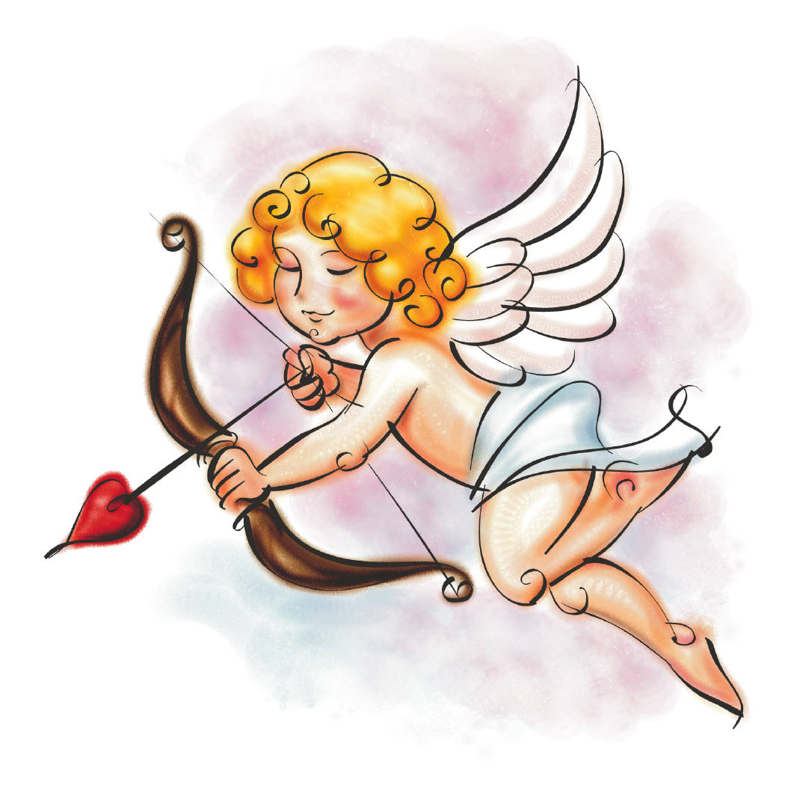

Shootout Continued from page 2

to Minnesota to rob a bank, the good citizens of Northfield shot them to pieces, and all but Frank and Jesse James were wounded, captured, or killed. Seventeen years later, the Dalton boys decided to rob two banks at once in Coffeyville, Kansas. Trouble was, the supposedly knock-kneed townies got wind of the plan. They armed themselves, and firing from rooftops, lofts, windows, alleys, and eventually from the street, they blew the Daltons’ grand strategy to hell. Only Emmett Dalton survived to spend the next fifteen years in prison. Both of those scenarios would make darn good team events, and you would have lots of help as you drew your guns against those fifteen bad guys. And that’s pretty much how it really was.

But what of the equally traditional one on one, mano a mano—the two-man walk down and shootout in the middle of the street? We’ve seen plenty of those in the movies and on TV. For more than fifteen years, every episode of Gunsmoke began with just such a scene. Then, in the late sixties, CBS got “non-violent,” and replaced the opening sequence with incongruous footage of Matt Dillon racing a train on his horse. But I digress. What about those fast draw contests? Well, for one thing, they would make for a pretty boring Cowboy Action Shooting stage. Here’s the scenario:

1 Pistol round 0 Rifle rounds 0 shotgun rounds

Pistol is loaded with 1 round, holstered. Shooter is standing in the circle. On the beep, draw pistol, engage cowboy one time. Holster pistol. Proceed to unloading table.

Even if you got to yell, “This town ain’t big enough for the two of us,” or, something similar, it would be over with pretty quickly. True, you do sometimes see something similar at some annual matches, in what’s called a man on man, or one on one, side match. But as a main match stage, not so good. However, even if it wouldn’t make a great stage, there actually is a historical precedent for this Hollywood staple, and it involves no less an old west legend than Wild Bill Hickok.

Following his war service with the Union army, Wild Bill settled in Springfield, Missouri, dividing his time between card playing, drinking, and skirt chasing. All of these pastimes played a part in leading to a street fight with another gambler named Davis Tutt. Tutt and Hickok were rivals for the affections of the same woman, and in that contest, Wild Bill wound up on top, so to speak. When Tutt later won Hickok’s watch in a poker game, it may have taken some of the sting out of losing at love, but it also led to his death. As he handed over the watch, Wild Bill told Tutt if he ever tried to show him up by wearing the watch in public, there’d be hell to pay. Tutt did, and there was.

The fight was egged on by a bored barfly who probably just wanted to liven things up a bit. Hickok was drinking away the afternoon one day when the barfly in question told him Davis Tutt was out walking around in the town square, wearing Wild Bill’s watch. After a few more drinks, Wild Bill was mad enough to go outside to check it out. He yelled at Tutt across the square, and they exchanged insults while walking toward one another. Hickok’s prowess with a six-gun was well known around Springfield, so Tutt surely was aware of it. A more prudent man might have removed the watch from his vest, or even offered to give it back. But for reasons he took with him to his grave, Tutt drew a revolver and took a shot at Wild Bill from across the square, a distance of somewhere between 60 and 100 yards. In response, Wild Bill also fired a single shot. Tutt missed, and that miss cost him a lot more than 5 seconds, because the bullet from Hickok’s Model 1851 Colt found Davis Tutt’s heart.

There were no doubt other fights of this sort, but surely not as many as we grew up believing. Most old west killings were of the “lead pipe cinch” variety, such as two barrels of 00 buck at 5 paces, or a rifle bullet to the back fired from a dark alley. We get into more gunfights on a single Saturday than the typical westerner did in his entire life, and I expect most of us have run more rounds through single action revolvers than Wyatt Earp, Billy the Kid, and John Wesley Hardin ever did, combined.

As I said before, I’m just glad our bad guys stand still and don’t shoot back. And I don’t believe I would have taken that shot at Wild Bill. I think I would have given the watch back instead, and told him he could keep the girl, too.

The End

