 THE VIGILANTE 
Volume 18 Issue 4 Editor: Nasty Newt SASS # 7365 December 2015

The Monthly Chronicle of the Robbers Roost Vigilantes

Bolt Action Turkey
Number Two with a Bullet
Some of you oldsters will remember years back when rock bands had strange names like Strawberry Alarm Clock, Jefferson Airplane (later Starship), and Deaf Leopard (later changed to Def Leppard). Steve Allen made sport of it by drawing an adjective out of one jar and a noun out of another and putting them together to form the name of the next hit band, such as Left-handed Turnip or Manly Applesauce. In December the RRV coined a name for a bunch of hard core shooters, Bolt Action Turkey.
Seven shooters brought out their old bolt action rifles on the 12th, including Justin O Sheriff, Red Rock, and Shortstock. It was great to see them all again. We had plenty of failures to feed, stubborn bolts, and just plain misses, but we had a ball doing it. Justin O Sheriff left the rest of us in his dust, which he often does no matter what kind of guns we’re shooting. Special thanks to Death Valley Rose for keeping score and keeping track of the door prize tickets, not to mention the cookies.
On the 19th it was back to CAS for the Turkey Shoot. That match drew thirteen shooters, including Augustus Bulleit and Kalroy from Boron, and a fellow named Kris Kringle from parts North. Thanks for coming, guys. The stages by Venomous Doc, Bad Bascomb, and your humble editor featured numerous opportunities to earn tickets in the drawing, and Death Valley Rose was busy keeping track of who got what, and handing out the tickets. Bad Bascomb won the match going away, as is his custom. Venomous Doc and M.C. Ryder were 2 and 3, and yours truly edged out Kris Kringle by about a second for 4th place. I’m getting a lump of coal for sure. Wrangler Red shot the match clean. Good shooting! The scores from both matches are posted.
After the smoke had cleared, we repaired to the cantina for the drawing. M.C. Ryder won the turkey (a $50 gift card from GUNS4US). The rest of us won baked goodies from Death Valley Rose and Desert Willow. There wasn’t a loser in the place! Continued on page 2

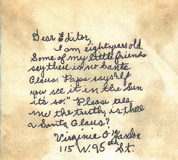
The above letter to the editor was written by 8-year-old Virginia O’Hanlon and received by the New York Sun in 1897. The paper’s response, written by Francis Church, has gone on to be the most reprinted English language editorial of all time. So, here we go again!

“Virginia, your little friends are wrong. They have been affected by the skepticism of a skeptical age. They do not believe except they see. They think that nothing can be which is not comprehensible by their little minds. All minds, Virginia, whether they be men's or children's, are little. In this great universe of ours, man is a mere insect, an ant, in his intellect as compared with the boundless world about him, as measured by the intelligence capable of grasping the whole of truth and knowledge.

Yes, Virginia, there is a Santa Claus. He exists as certainly as love and generosity and devotion exist, and you know that they abound and give to your life its highest beauty and joy. Alas! how dreary would be the world if there were no Santa Claus! It would be as dreary as if there were no Virginias. There would be no childlike faith then, no poetry, no romance to make tolerable this existence.”

Continued on page 2

INSIDE THIS EDITION
1 From the President 2 Proof Santa is Real
1 Yes, Virginia… 3 RRV Shooting schedule
2 Upcoming CAS matches 4 &5 Match Photos

2 Upcoming Events

Information
4 Where is “Why the West Was Won” ?

UPCOMING EVENTS
The Cajon Cowboys shoot on the: 2nd and 4th Saturday at the Gem Ranch in the Cajon Pass on old route 66. Contact Luke Warmwater at (909) 987-7017. www.cajoncowboys.com.
Five Dogs Creek Cowboys in Bakersfield shoot on the 1st weekend of each month. Call Utah Blaine, (661) 203-4238. www.5dogscreek.com
High Desert Cowboys shoot in Acton on the 3rd Sunday. Contact Doc Silverhawks, (661) 948-2543, or Lumpy Grits or Ima Schofield at (661)265-1923.
Double R Bar Regulators, Lucerne Valley, shoot the 2nd Sunday. www.rrbar.com. Contact Little Jersey Jo, 1-760-247-5012, joed56676@gmail.com.
 He’s Real, All Right!
Making glad the heart of childhood.
Continued from page 1

In January we are NOT SHOOTING on the 2nd. Our third Saturday match will be on the 16th. We’re now on Winter Hours, so we’ll start sign ups at 8:00, and have the meeting at 8:45.
The new shooter class would be at 7:30. Please let us know if you’re bringing a new shooter so one of our instructors can be prepared to take of them.

Robbers Roost Vigilantes
Executive Board
President
Nasty Newt
Vice President
Bad Bascomb
Secretary
Goode Bascomb
Treasurer
Desert Willow
Territorial Governor
M. C. Ryder
Range Officer/Sgt. at Arms
Cowboy Earl
Match Director Emeritus
Just George
The Robbers Roost Vigilantes Executive Board and the editor of The Vigilante are not responsible for mishaps of any nature that might occur from the use of published loading data or from the recommendations by any member of the staff, guest writers, or from products sold by advertisers.

Yes, Virginia, There is a Santa Claus continued from page 1
“We should have no enjoyment, except in sense and sight. The external light with which childhood fills the world would be extinguished. Not believe in Santa Claus! You might as well not believe in fairies. You might get your papa to hire men to watch in all the chimneys on Christmas Eve to catch Santa Claus, but even if you did not see Santa Claus coming down, what would that prove? Nobody sees Santa Claus, but that is no sign that there is no Santa Claus. The most real things in the world are those that neither children nor men can see. Did you ever see fairies dancing on the lawn? Of course not, but that's no proof that they are not there. Nobody can conceive or imagine all the wonders there are unseen and unseeable in the world.
You tear apart the baby's rattle and see what makes the noise inside, but there is a veil covering the unseen world which not the strongest man, nor even the united strength of all the strongest men that ever lived could tear apart. Only faith, poetry, love, romance, can push aside that curtain and view and picture the supernal beauty and glory beyond. Is it all real? Ah, Virginia, in all this world there is nothing else real and abiding.
No Santa Claus! Thank God! He lives and lives forever. A thousand years from now, Virginia, nay 10 times 10,000 years from now, he will continue to make glad the heart of childhood.”

Business Card Advertising


BAD BASCOMB SASS #47,494
(aka MARI TODD)

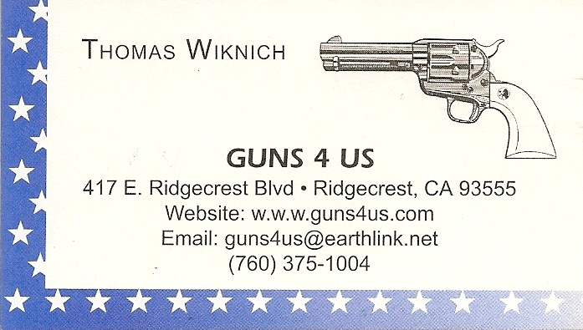
NAME BRANDS TO SURPLUS
QUALITY CLOTHING & EQUIPMENT
FOR TRAIL OR TRAVEL
(760) 375-7223

COLLINS GUNSMITHING
MODERN ANTIQUE REPLICA
ACTION JOBS BLUEING STOCK WORK
FOR ALL YOUR REPAIRS AND SERVICE
760-375-5703

How to Join the Robbers Roost Vigilantes…
Come out to a RRV match, held the third (and sometimes first) Saturday of every month, or call Nasty Newt at 760-375-7618, or MC Ryder at 760-384-2321, or mail it in. Our membership application is here RRV Membership Application Annual membership dues for the RRV are: single membership $25, member and spouse $30, family membership (including children under 18 living at home) $35. First time shooters will be able to take their FIRST (1) NEW SHOOTERS CLASS for $10, any subsequent new shooters class or RRV match shoot will be $10 members, $15 nonmembers. Donations for shooting regular monthly RRV matches will be $10 members, $15 non-members. Memberships run from September 1 - August 31. New memberships purchased after September will be prorated depending on the number of months remaining and the type of membership. RRV members are encouraged to become Single Action Shooting Society (SASS) members. Please call SASS at 877-411-SASS. SASS membership information can be found here:

http://www.sassnet.com/Membership-Main-001A.php

SASS membership is not required for membership in RRV, or participation in RRV regular monthly matches. RRV encourages all shooters to join and support the NRA and the NRA Foundation, and Ridgecrest Gun Range Association. For further information visit our website at www.robbersroostvigilantes.com.



f
Schedule of Monthly Matches
RRV Match Dates:
January 2, 2016 NO MATCH

January 16, 2016

Winter Hours: Sign up starting ~ 8:00, Safety Meeting ~ 8:45.



mm

Photos from the Turkey Shoot
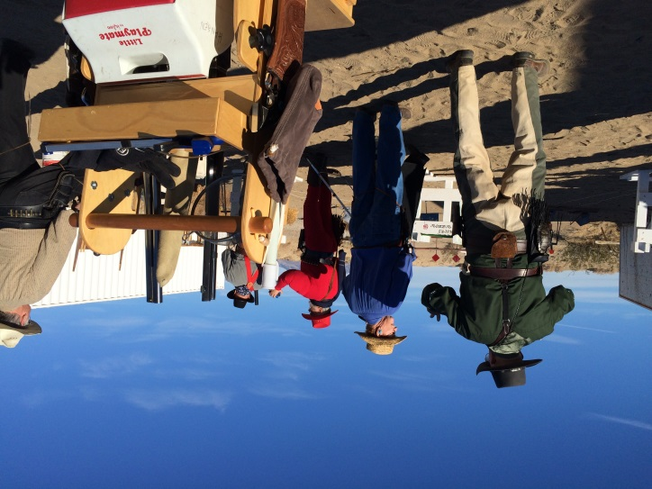
Venomous Doc explains the Jack Daniel’s Sweep.


Augustus Belleit and Zig Mar keep an eye on the mysterious Man in Black

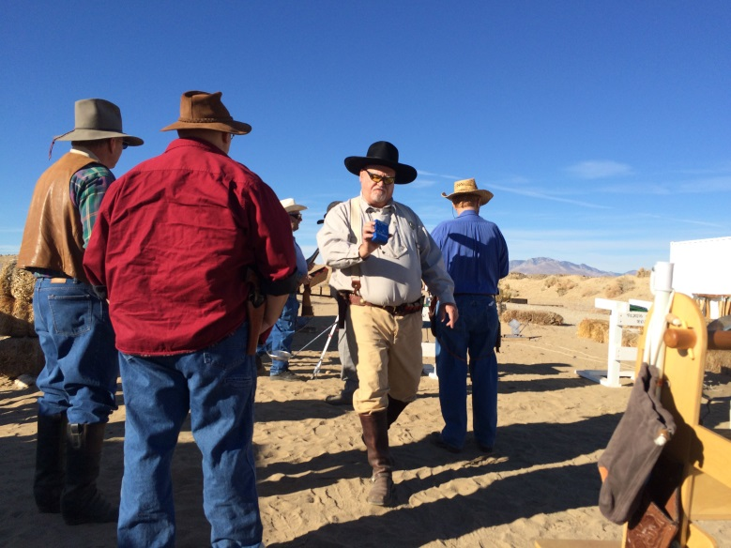
Walking, talking and reading simultaneously—but not chewing gum.
Photos by Death Valley Rose.

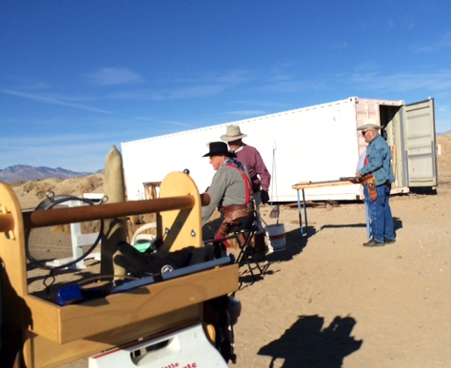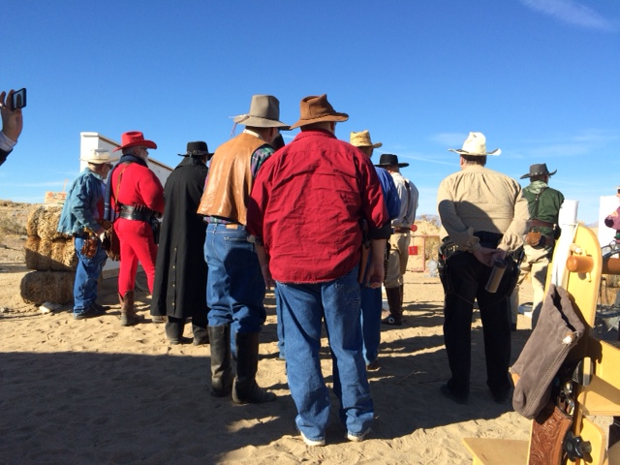
Wrangler Red waits for a customer Who knew they allowed naked ladies on the range?

Photos from the BAMM Match

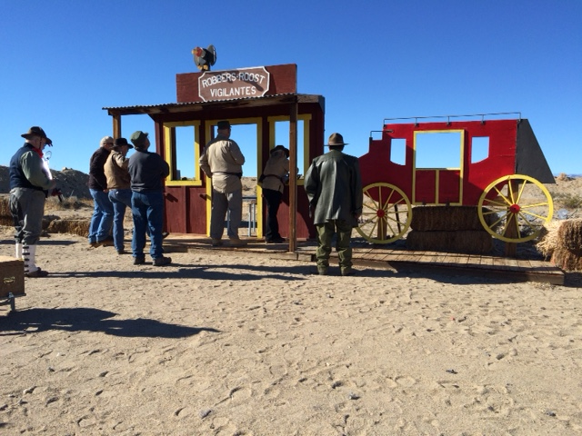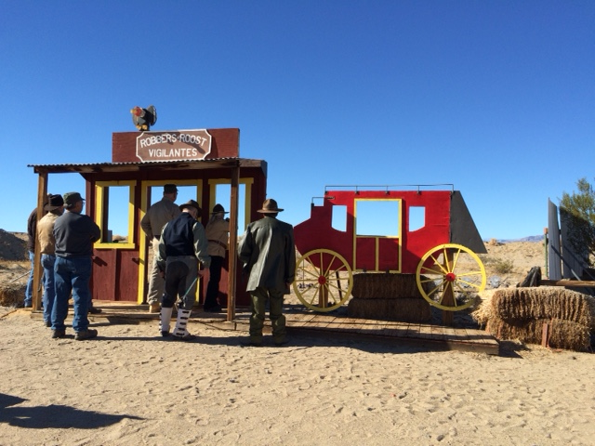

Shortstock wrestles with her Russian M38 carbine… …and gets it shooting

Photos by Death Valley Rose

