 THE VIGILANTE 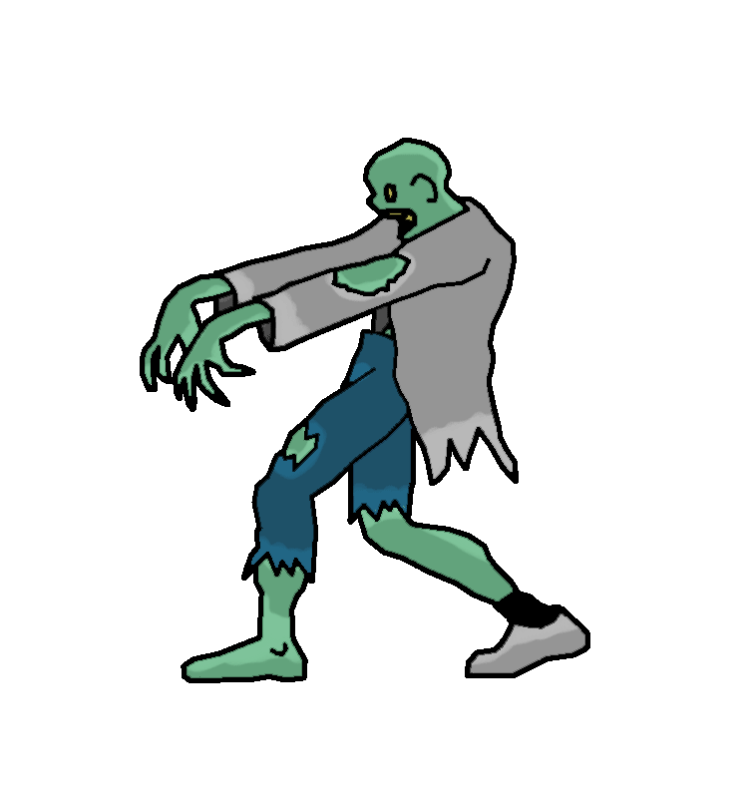
Volume 20 Issue 7 Editor: Nasty Newt SASS # 7365 Match 2018

The Monthly Chronicle of the Robbers Roost Vigilantes

From the President
Leprechauns Are Hard to Kill
Then Sometimes They Come Back as Zombies
The weatherman wasn’t very nice to the RRV this month. He can be a friend or foe around here this time of year, and for March, he was mostly a foe, at least on match days.
It was very cold and windy for our first Saturday match on the 3rd. Only five hardy souls (or is it foolhardy?) came out to shoot. It was a challenge, and you really had to want to be there, but we had a fun match shooting great stages by M.C. Ryder and Bad Bascomb. Bad Bascomb, Venomous Doc, yours truly, M.C. Ryder, and Silver Badger all earned our spurs on that day. Nobody shot it clean.
The muzzle loader trail walk on the 10th was better attended, but the rain that was supposed to hold off until the afternoon didn’t quite make it. It started sprinkling early, and by the time the last shot went down range we were shooting in a light but steady drizzle. As promised, Cowboy Earl had us putting out a lot of pistol balls and bird shot along with the rifle balls, and this ended up being the shootingest RRV trail walk ever. Eight shooters came out, and we all managed to keep our powder dry. When the smoke had cleared, Ed Hinkley had cleaned our clocks, as usual, trailed by John Newton, me, M.C. Ryder and Cowboy Earl in the top five.
It was darn near as cold and windy on St. Patrick’s Day as it was on the 3rd, but we got nine shooters out, and each of us had the honor of destroying a can of Busch beer in mid-air with the scattergun. It’s hard to miss when you have that kind of motivation. We didn’t shoot the Guinness; we drank that later. We also had to deal with some troublemaking leprechauns, but then the little devils came back as zombies, so we had to do ‘em again. You gotta do what you gotta do. As is his custom, Bad Bascomb shot a great match and lapped the field. M.C. Ryder, Duelin’ Tom, Cowboy Earl, and your humble editor rounded out the top five. Nobody shot it clean. Continued on page 2

Ben Johnson
by
Nasty Newt
SASS #7365

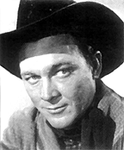
Ben Johnson

June 13, 1918 – April 8, 1996

Ben “Son” Johnson, Jr., was born in Foraker, Oklahoma. Though he was known professionally as Ben, throughout his life his friends and family called him Son. When not ranching, Son and Ben Sr. were champion rodeo performers, and Ben Sr. is in the Rodeo Hall of Fame and Hall of Great Westerners.

In 1939, Howard Hughes hired Son to take a load of horses to California. The pay was good so he stuck around, and for some years was a stunt man, horse wrangler, and double for such stars as John Wayne, Gary Cooper and James Stewart. His break came when John Ford noticed him and gave him a part in an upcoming film, and eventually a starring role in Wagon Master (1950).

Rodeo was still Ben’s first love, though, and he left Hollywood to return to it 1953. He won a world roping championship that year but barely broke even. He said he came out of it with no money and a mad wife, so he returned to the west coast and a lucrative acting career that spanned hundreds of films.
Continued on page 2

INSIDE THIS EDITION
1 From the President 3 April Match Schedule
1 Ben Johnson

2 Upcoming Events

Information
4 Where is “Why the West Was Won” ?

Ben Johnson ctinued from page 1
In spite of his leading man good looks, Ben Johnson spent his long career mostly as a supporting actor in a string of outstanding films such as “Shane” (1953), “Cheyenne Autumn” (1964), Will Penny (1967) and “The Wild Bunch” (1969). He was featured in no fewer than eight John Wayne movies, and the two became close friends. John Wayne said Ben loved to ride, and he never saw anybody that could ride better than Ben. If you see a scene of somebody that looks like Ben Johnson racing across the desert or jumping a gully, it ain’t no stunt man.
In 1971 Ben Johnson won an Academy Award for Best Supporting Actor in “The Last Picture Show,” a part that he originally turned down. Son was a straight arrow, and he was appalled by the foul language that permeated the script. He said he would take the part only if the “dirty words” were removed from the lines delivered by his character, Sam the Lion. The director, Peter Bogdanovich, agreed. In a bit of irony, at one point in the movie Sam the Lion says, “I've been around that trashy behavior all my life, I'm gettin' tired of puttin' up with it.” Son could have written that.
Ben Johnson was married for 53 years to Carol Jones, the daughter of noted Hollywood horse wrangler “Fat” Jones. They had no children.
Our own Fullmoon’s Aunt Jean and her cousin Bubbles, (her real name) grew up with Son, and rode horses and hung out with the Johnsons on the Chapman Barnard ranch in Personia, OK.
continued below
From the President Continued from page 1

All of the scores from all three matches are posted.

In April we’re shooting cowboy matches on the 7th and the 21st, and a trail walk is planned for the 14th. There is the possibility of a BAMM on the 28th. So, load up your rifle ammo and watch your email and look at the web site.
We’re on Winter Hours, so we will start signups around 8:00 and try to have the meeting by 8:45.

Robbers Roost Vigilantes
Executive Board
President
Nasty Newt
Vice President
Bad Bascomb
Secretary
Goode Bascomb
Treasurer
Desert Willow
Territorial Governor
M. C. Ryder
Range Officer/Sgt. at Arms
Cowboy Earl
Match Director Emeritus
Just George
The Robbers Roost Vigilantes Executive Board and the editor of The Vigilante are not responsible for mishaps of any nature that might occur from the use of published loading data or from the recommendations by any member of the staff, guest writers, or from products sold by advertisers.

Ben Johnson Continued from above
Fullmoon’s great uncle Clyde was the foreman of the ranch for many years. Aunt Jean still recalls the time Son took the horses out west for Howard Hughes.
Editors’s Note: The above is taken mostly from the 2008 Defend the Roost Shooter’s Handbook. The theme was western sidekicks, and Ben Johnson was one of them. I can’t quite believe it’s been ten years, but apparently it has. I e-mailed Just George and Fullmoon to inquire about Aunt Jean, and Fullmoon replied as follows:
“My Aunt is 90 now. As a matter of fact, I was just visiting her an hour ago. She's in a memory care facility, but her long term memory is well intact. Just don't ask her what she had for lunch. Tell Debbie (Desert Willow) that my aunt is a real Lonesome Dove fan. Therefore, the painting of Robert Duvall that she painted is hanging in my aunt’s room.... along with a picture of Son Johnson. Good ole Oklahoma.”

It probably isn’t quite fair to say they don’t make ‘em like Ben Johnson and Aunt Jean anymore. But they darn sure don’t make very many.

Business Card Advertising


BAD BASCOMB SASS #47,494
(aka MARI TODD)


NAME BRANDS TO SURPLUS
QUALITY CLOTHING & EQUIPMENT
FOR TRAIL OR TRAVEL
(760) 375-7223
How to Join the Robbers Roost Vigilantes…
Come out to a RRV match, held the third (and sometimes first) Saturday of every month, or call Nasty Newt at 760-375-7618, or MC Ryder at 760-384-2321, or mail it in. Our membership application is here RRV Membership Application Annual membership dues for the RRV are: single membership $25, member and spouse $30, family membership (including children under 18 living at home) $35. First time shooters will be able to take their FIRST (1) NEW SHOOTERS CLASS for $10, any subsequent new shooters class or RRV match shoot will be $10 members, $15 nonmembers. Donations for shooting regular monthly RRV matches will be $10 members, $15 non-members. Memberships run from September 1 - August 31. New memberships purchased after September will be prorated depending on the number of months remaining and the type of membership. RRV members are encouraged to become Single Action Shooting Society (SASS) members. Please call SASS at 877-411-SASS. SASS membership information can be found here:
http://www.sassnet.com/Membership-Main-001A.php

SASS membership is not required for membership in RRV, or participation in RRV regular monthly matches. RRV encourages all shooters to join and support the NRA and the NRA Foundation, and Ridgecrest Gun Range Association. For further information visit our website at www.robbersroostvigilantes.com.



Schedule of Monthly Matches
RRV Match Dates:
April 7, 2018 Cowboy
April 14, 2018 Trail Walk
April 21, 2018 Cowboy
April 28, 2018 BAMM (Tentative)
Winter Hours: Sign up starting ~ 8:00, Safety Meeting ~ 8:45.

John Wayne, Harry Carey, Jr., Ben Johnson, John Agar and Victor McLaglen in
“She Wore A Yellow Ribbon”


