 THE VIGILANTE 
Volume 20 Issue 9 Editor: Nasty Newt SASS # 7365 May 2018

The Monthly Chronicle of the Robbers Roost Vigilantes
From the President
Mayday! Mayday!
We had some wind this May, as usual. As the saying goes, when it comes to wind, “March has the name, but May has the game.” This is also the month I turn 70. That’s kind of hard for me to understand, what with me being a kid and all, but my son is 51, so I guess it must be true. I will celebrate my birthday by driving up to the Lake Isabella DMV office to renew my license. I tried to make an appointment in Ridgecrest, but the first available appointment was after my expiration date. I decided I would just walk in and wait, but there were about forty people ahead of me, a half-hour after they opened. Tried for a Lake Isabella appointment and got one, on my birthday. Now I have to pass the test.
May was a good month to be a Vigilante, as we were out there three times. We were planning to make it four but called off the BAMM that had been scheduled for Memorial Day Weekend.
On the 5th I decided to burn some BP, so I broke out the 1860 Henry and hammer double, but I should have left them in the safe. I did not impress, to say the least. Bad Bascomb, Venomous Doc, Zig Mar, MC Ryder, Goode Bascomb Silver Badger, and yours truly was the order of finish.
I burned the same BP at the trail walk on the 12th, but in very different guns, and did marginally better. MC Ryder and John Newton gave Ed Hinkley a run for his money, but as a horse-racing enthusiast friend of mine used to say, “They don’t pay at the quarter pole.” Ed pulled away late and won the match, followed by MC, John, your humble editor, Cowboy Earl, and Zach Newton.
Zig Mar wrote six great stages for the 19th, which was Armed Forces Day, and eight of us turned out to shoot them. It was a fun match, and Venomous Doc nipped at Bad Bascomb’s heels a little bit, but to no avail. MC Ryder, Cowboy Earl, yours truly, Zig Mar, Wrangler Red, and Silver Badger were the also-rans.
And on Memorial Day, remember to take a moment to honor those who continued on page 2
Continued on page 2

The End of Another Era
by
Nasty Newt, SASS # 7365
Well, here I am again, waxing philosophic about change. I did it when Coso Kid and Kazarah Jane resigned from the club and moved away, leaving us to muddle along without them. Let me tell you, that was a BIG change. I did it again when we stopped mailing out hard copies of this newsletter. Some of our members, including me, still like to hold a piece of paper in their hand and read it, but it just didn’t make sense to continue using snail mail. Then a few years back I was at it again when we very reluctantly came to the realization that we couldn’t continue putting on Defend the Roost.
So, what am I whining about this time? Well, a few weeks back I informed you via e-mail that publication of The Vigilante as a monthly newsletter was going to cease, and so it is. The one you are reading right now, May 2018, issue number nine of year number twenty, is the end of that era. From now on the newsletter will be published quarterly, in March, June, September, and December.
However, right off the bat, I am deviating from the new schedule. June is going to be a busy month for me, as it usually is, so there won’t be a newsletter in June. The next one will be in September.
Coso Kid, the original editor, once remarked to me that he didn’t especially like doing
Continued on page 2

INSIDE THIS EDITION
1 From the President 3 June Match Schedule
1 Quarterly Era Begins 2/3 Clint Walker

2 Upcoming Events

Information
4 Where is “Why the West Was Won” ?

Newsletter continued from page 1

the newsletter, but he felt that it was something a successful club needed to do. Well, almost twenty years later, I’d say we’ve been successful, so it’s probably safe to back off a little bit.
As Coso Kid and Kazarah Jane were preparing to leave and transitioning out of their RRV responsibilities, I took over as the newsletter editor. The first one I can find with my name on it is Volume 9, Issue 4, December 2006. So, I’ve been at it a while.
I’m a writer; always have been, and always will be (note the use of the good old semicolon 😊). I’m pretty good at it, but writing is work for me, and I don’t particularly enjoy doing it. I enjoy having written. It’s nice to kick back and read your own work and be able to say, “That’s not bad. I like it.”
I’m also a pretty good editor, and I can fit stuff into the space available. I learned how to do that back in ’95 and ’96 when I was writing a weekly column for The Daily Independent. I had a limit of 700 words, and if I couldn’t say what I wanted to say in 700 words or less, they would cut it for me. I quickly realized I didn’t want them doing that, so I learned to edit, painful as it sometimes is when you have to take something out that you really would like to be able to leave in. Just part of the job.
Many club members have submitted articles and photos over the years, and I appreciate everything everybody did. But after almost 150 newsletters, I’m finding it harder and harder to get motivated to do the work.
I’m not resigning, just slowing down, and unless I get fired, I plan to continue editing The Vigilante as a quarterly into the foreseeable future. And, as always, if you have anything you’d like to submit for publication, you know where to find me. I don’t have any of those dreaded form rejection slips, and don’t plan on getting any.

From the President Continued from page 1

made the supreme sacrifice in the service of our country, and for you and me.

In June we start the “out and about” season. We are NOT shooting on June 2. June 16 is up in the air, and whether we will shoot is to be determined. Watch you e-mail for further information!
We’re on Summer Hours, so we will start signups around 7:00 and try to have the meeting by 7:45.

Robbers Roost Vigilantes
Executive Board
President
Nasty Newt
Vice President
Bad Bascomb
Secretary
Goode Bascomb
Treasurer
Desert Willow
Territorial Governor
M. C. Ryder
Range Officer/Sgt. at Arms
Cowboy Earl
Match Director Emeritus
Just George
The Robbers Roost Vigilantes Executive Board and the editor of The Vigilante are not responsible for mishaps of any nature that might occur from the use of published loading data or from the recommendations by any member of the staff, guest writers, or from products sold by advertisers.

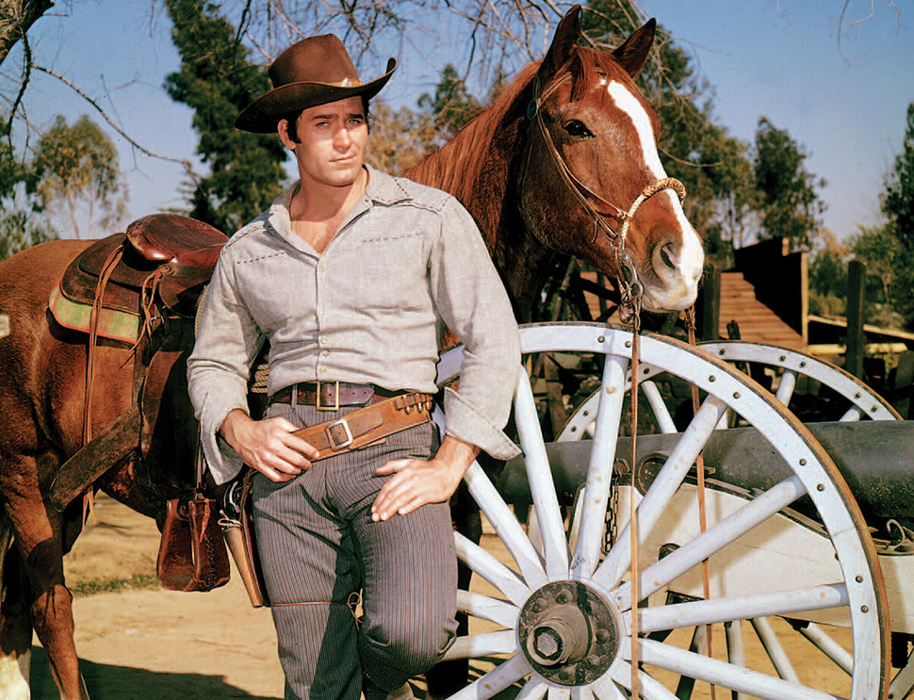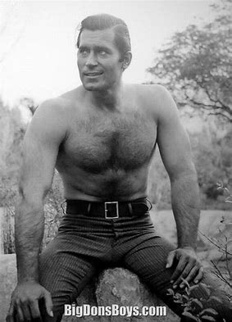
Clint Walker, May 30 1927 – May 21, 2018

Business Card Advertising


BAD BASCOMB SASS #47,494
(aka MARI TODD)


NAME BRANDS TO SURPLUS
QUALITY CLOTHING & EQUIPMENT
FOR TRAIL OR TRAVEL
(760) 375-7223
How to Join the Robbers Roost Vigilantes…
Come out to a RRV match, held the third (and sometimes first) Saturday of every month, or call Nasty Newt at 760-375-7618, or MC Ryder at 760-384-2321, or mail it in. Our membership application is here RRV Membership Application Annual membership dues for the RRV are: single membership $25, member and spouse $30, family membership (including children under 18 living at home) $35. First time shooters will be able to take their FIRST (1) NEW SHOOTERS CLASS for $10, any subsequent new shooters class or RRV match shoot will be $10 members, $15 nonmembers. Donations for shooting regular monthly RRV matches will be $10 members, $15 non-members. Memberships run from September 1 - August 31. New memberships purchased after September will be prorated depending on the number of months remaining and the type of membership. RRV members are encouraged to become Single Action Shooting Society (SASS) members. Please call SASS at 877-411-SASS. SASS membership information can be found here:
http://www.sassnet.com/Membership-Main-001A.php

SASS membership is not required for membership in RRV, or participation in RRV regular monthly matches. RRV encourages all shooters to join and support the NRA and the NRA Foundation, and Ridgecrest Gun Range Association. For further information visit our website at www.robbersroostvigilantes.com.



Schedule of Monthly Matches
RRV Match Dates:
June 2, 2018 No Match
No Trail Walk
June 16, 2018 To be Determined
No BAMM
Summer Hours: Sign up starting ~ 7:00, Safety Meeting ~ 7:45.

So long, Cheyenne. Rest in Peace.
Clint Walker died on May 21st, a few days short of his 91st birthday, a birth date he shared with me, by the way. A piece of my childhood died with him.

The golden age of the television western came along at just the right time for me, and I dearly loved being a little boy back then. Cheyenne Bodie was one of my heroes, a gentle giant who wouldn’t hurt a fly, but you didn’t want to mess with him. If a wrong needed righting, he would take care of it. He was a man’s man, and also got a lot of sidelong glances from the ladies. My mother watched Cheyenne right along with me.

Clint Walker had a career after Cheyenne, but like most TV western headliners, he never became a big star. He sure had an impact on me, though. As I said on the SASS Wire the other day, “Guys like him are the reason guys like me are cowboy action shooters.” NN
https://www.bing.com/videos/search?q=cheyenne+theme+song+youtube&&view=detail&mid=7D90223DC931FAD755AA7D90223DC931FAD755AA&rvsmid=F83C4DD09B2729B9CBB5F83C4DD09B2729B9CBB5&FORM=VDQVAP

