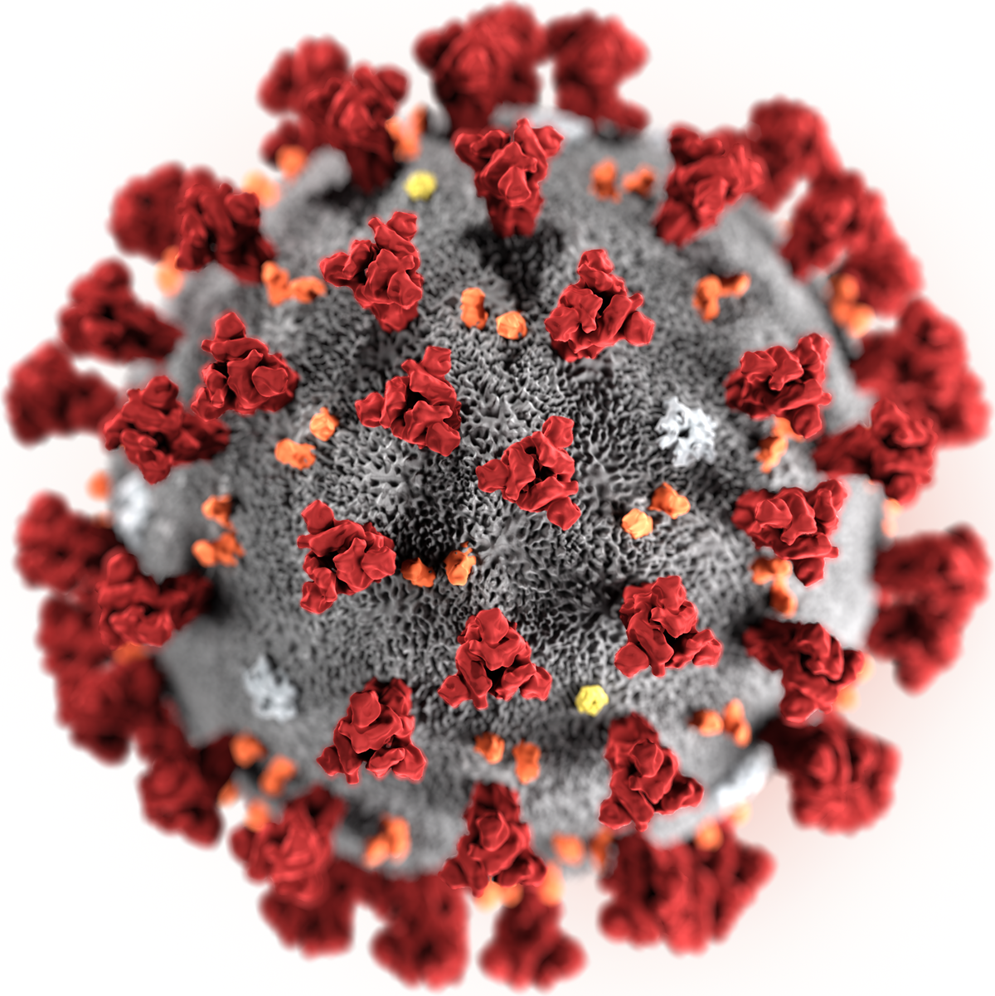 THE VIGILANTE 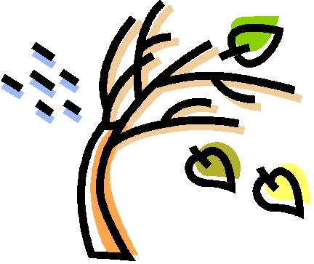
Volume 23 Issue 3 Editor: Nasty Newt SASS # 7365 Spring 2021

The Quarterly Chronicle of the Robbers Roost Vigilantes
From the President
2020 was a rough time for all of us. At home and on the range, we all had to figure out how we were going to proceed in life and live with Covid, and how to process all the confusing and often aggravating guidance we were getting from all directions. The RRV took a month off, but other clubs with much greater attendance were shooting. We don’t often exceed ten shooters, and recreational facilities were exempted from the ten-person guideline anyway, so we decided to make masks optional, do our best to distance, and shoot. I think that was a good decision.
The first three months of 2021 haven’t exactly been anything to write home about. Death Valley Rose continues to recuperate from major surgery, and I think I’m about over my Covid adventure that began with the New Year. I thought that before, then came down with an infection that put me in the hospital for almost two weeks. I’m knocking on wood as I write this. There are several RRV stalwarts that haven’t shot in a while for various reasons, and we are hoping to see them out there again real soon.
But this spring does have its bright spots. Jayne Cobb built, and with able assistance from Derriel Book and Sir Misalot, installed a spanking new façade on the Depot set. Cowboy Earl painted it and made and installed a new RRV sign, and replaced the boardwalk. It is starting to look like its old self again. That darn wind got a piece of the Pueblo, too, but Cowboy Earl has a plan for that as well. Thanks, guys. All your hard work is sincerely appreciated.
We have gotten in a lot of shooting this winter. (I use the royal “we”; I haven’t fired a shot since December) and a lot of it has been on cool, blustery days, including the recent trail walk on March 13 and the third Saturday shoot on March 20. When a Vigilante wants to bust some caps, a little weather isn’t going to get in the way. As always, those scores have been posted on the web site by our peerless webmaster, M. C. Ryder. Thanks M. C.
Continued on page 2

WYATT’S BUNTLINE SPECIAL

By Nasty Newt, SASS # 7365

If you’re like me and were fortunate enough to be a kid when there was at least one western series on television every night, you probably watched The Life and Legend of Wyatt Earp, starring Hugh O’Brian, and marveled at his prowess with his Buntline special. He could clear leather and buffalo a bad guy so fast that you could scarcely see his hand move. There was no doubt some fancy editing involved, because even from a tied-down buscadero rig it’s going to take a little time to get a 12-inch Colt single action into play. The entire Buntline Special story has been called into question, and dismissed as a myth by many historians.

But is it? Disinclined as he was to negotiate surrender terms with armed drunks, Wyatt Earp preferred to steal up from behind and buffalo them (whack them on the head) with his revolver. Although a 4 and ¾ inch barrel would do the job, Colt did make their Single Action Army in about any barrel length you might want, up to 16 inch and even longer. Given the fact that such guns existed in his lifetime, the three questions I would like answered are (1) Did Wyatt Earp really own one? (2) If so, did he use it in the OK Corral fight? and (3) Where is it?

As far as anybody knows, the Buntline Special story first saw light of day in Stuart N. Lake’s biography, Wyatt Earp, Frontier Marshal. The book was published in 1931, two years after Earp’s death. Lake had interviewed Earp, and claimed the old lawman said that in 1876, dime novelist Ned Buntline gave five westerners--Earp, Bat Masterson, Charlie Bassett, Bill Tilghman and Neil Brown, Colt .45s with 12-inch barrels. The writer allegedly made these presentations out of gratitude for all the story fodder he had gleaned from knowing these noted gun hands. continued on page 2

INSIDE THIS EDITION
1 From the President 3 Match Schedule
1 Wyatt’s Buntline
2 Photos of Buntline and a Buntline

2 Upcoming Events

Information
4 Where is “Why the West Was Won” ?

Wyatt’s Buntline continued from page 1
I believe Wyatt Earp was perfectly capable of making up the whole Buntline story to spice up the book. In their later years both he and Masterson weren’t above passing off old pawnshop Colts as guns they had used on the frontier as they were going about the taming of the wild west. Masterson even cut bogus notches in the handle of one such gun for an admiring New Yorker, and Earp supposedly would take his fakes out and run a few rounds through them so he could say with a straight face that he had used the guns.

Stuart Lake appears to have believed the Buntline Special story. Either that, or he did a really good job of running out the fake. He wrote several letters, including two to members of the Masterson family, and he wrote the Colt factory in an attempt to confirm the story. He mentioned in his letter to Colt’s that Earp had told him the guns were nothing more than white elephant gifts, and that Masterson and Brown had cut the barrels on theirs.

The Colt records of the day can neither confirm nor deny that Buntline ordered these guns, and none of the other supposed recipients ever mentioned them, but there is some circumstantial evidence to support the Buntline story. A witness who saw Wyatt Earp buffalo Tom McLaury on the morning of the OK Corral fight said he did it with a very long-barreled six-gun. If he carried it on the morning of October 26, 1881, wouldn’t he most likely have carried it later that afternoon, and used it to shoot Frank McLaury, and maybe Billy Clanton (depending on which version of "who shot whom" you choose to believe)? Seems logical, except that Earp always claimed he carried his revolver in his coat pocket that day, not in a holster, and that would take a pretty deep coat pocket. Also, on January 14, 1881, Buckskin Frank Leslie, a noted Arizona gunman, placed an order for a SAA with a 12-inch barrel. This is the very same day that Earp stood down a mob intent on lynching gambler Johnny-Behind-the-Deuce. Continued on page 3

From the President Continued from page 1

We’re still on Winter Hours, so we will start signups around 8:00, and try to have the meeting by 8:45, for all matches unless otherwise announced.

We normally switch to Summer Hours, and start an hour earlier, in May. Than back on Winter Hours in October.

Robbers Roost Vigilantes
Executive Board
President
Nasty Newt
Vice President
Bad Bascomb
Secretary
Goode Bascomb
Treasurer
Desert Willow
Territorial Governor
M. C. Ryder
Range Officer/Sgt. at Arms
Cowboy Earl
Match Director Emeritus
Just George
The Robbers Roost Vigilantes Executive Board and the editor of The Vigilante are not responsible for mishaps of any nature that might occur from the use of published loading data or from the recommendations by any member of the staff, guest writers, or from products sold by advertisers.

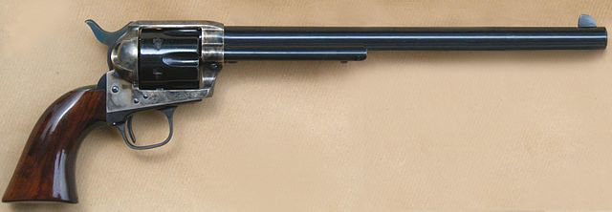 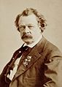 Ned Buntline

Business Card Advertising


BAD BASCOMB SASS #47,494
(aka MARI TODD)


NAME BRANDS TO SURPLUS
QUALITY CLOTHING & EQUIPMENT
FOR TRAIL OR TRAVEL
(760) 375-7223
How to Join the Robbers Roost Vigilantes…
Come out to a RRV match, held the third (and sometimes first) Saturday of every month, or call Nasty Newt at 760-375-7618, or MC Ryder at 760-384-2321, or mail it in. Our membership application is here RRV Membership Application Annual membership dues for the RRV are: single membership $25, member and spouse $30, family membership (including children under 18 living at home) $35. First time shooters will be able to take their FIRST (1) NEW SHOOTERS CLASS for $10, any subsequent new shooters class or RRV match shoot will be $10 members, $15 nonmembers. Donations for shooting regular monthly RRV matches will be $10 members, $15 non-members. Memberships run from September 1 - August 31. New memberships purchased after September will be prorated depending on the number of months remaining and the type of membership. RRV members are encouraged to become Single Action Shooting Society (SASS) members. Please call SASS at 877-411-SASS. SASS membership information can be found here:
http://www.sassnet.com/Membership-Main-001A.php

SASS membership is not required for membership in RRV, or participation in RRV regular monthly matches. RRV encourages all shooters to join and support the NRA and the NRA Foundation, and Ridgecrest Gun Range Association. For further information visit our website at www.robbersroostvigilantes.com.



Schedule of Monthly Matches
Matches are announced on the web site and via email to all club members. Cowboy matches are first and third Saturday. Usually, Trail Walks are second Saturday, and BAMM and Cowboy Rifle are fourth Saturday, when scheduled.
Winter Hours: Sign up starting ~ 8:00, Safety Meeting ~ 8:45.

Wyatt’s Buntline continued from page 2

And a 10-inch Colt was definitely delivered to Tombstone gunsmith Samuel L. Hart in May of 1882. Did Buckskin Frank and Hart order their guns after seeing Wyatt Earp put his to good use on the streets of Tombstone?

So, did Wyatt Earp own a Buntline Special, or didn’t he? Did he use it to buffalo Tom McLaury and kill Frank McLaury and/or Billy Clanton, and maybe several others during the subsequent “vendetta ride”? I think the answer is an unqualified, “Who the heck knows?” And if he did own it, what became of it? Well, Earp apparently told Stuart Lake he gave it to Charlie Hoxsie, his partner in a saloon in Nome, Alaska, in 1901. Unfortunately, or perhaps more accurately in this case, predictably, Hoxsie disappeared shortly thereafter. And that legendary revolver, if indeed it ever existed, and if Hoxsie had it, seems to have vanished along with him.
*******************
Editor’s Note: The above article is an edited version of a story I wrote for The Vigilante in 2009.

In the event you just can’t get enough of my writing about Wyatt Earp, I have a short article in the April Edition of Wild West Magazine entitled “Wyatt Earp’s Last Showdown.” It’s about his ill-fated 1910 foray into the Searles Valley as an armed guard for a party of claim jumpers intent on taking over some valuable mineral claims. His Buntline special is nowhere to be seen. Maybe he dropped it somewhere on the lake bed.

