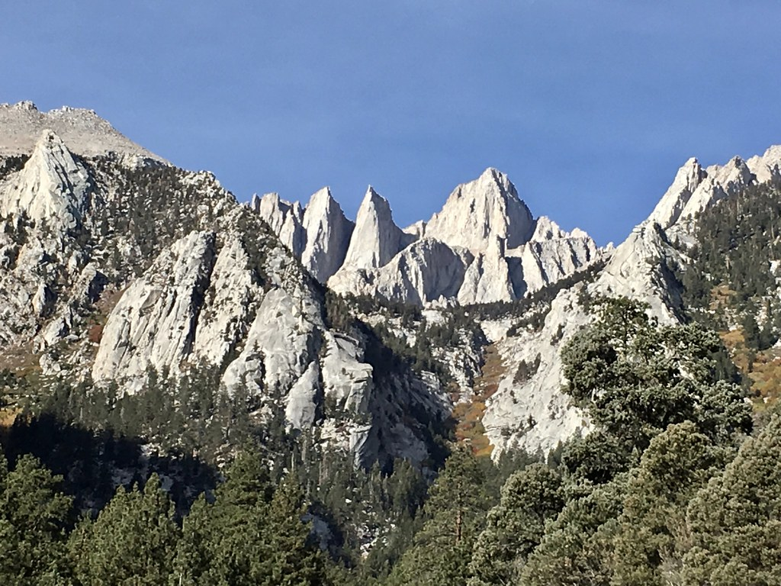 THE VIGILANTE 
Volume 25 Issue 3 Editor: Nasty Newt SASS # 7365 Spring 2023

The Quarterly Chronicle of the Robbers Roost Vigilantes
From the President
We Have World Champions
Coming Out of Our Ears
At our match on April 15, we had 12 shooters signed up in 7 categories. If I had been there, it would have been 13 shooters and 8 categories. That’s not at all unusual for Cowboy Action Shooting these days. But when I started in 1995, the categories were Traditional, Modern, Duelist, Frontiersman, and Senior, with ladies’ versions of all of them.
Times have changed just a bit over the years. It was a struggle getting Gunfighter category approved, one reason being that the early gunfighters were a whiny lot, and shed large tears over split pistol stages, pointing out between sobs that they were the only people in the whole wide world who were forced to shoot outside of their chosen category. Stage writers got so tired of hearing them snivel that split pistol stages, which had been a SASS staple since US Grant decided he needed to sell more guns and SASS went to two pistols, almost went extinct. Today we have Elder Statesman Frontier Cartridge Classic Cowboy Gunfighter. Hoo- boy. Just kidding, I think. But happily, today’s Gunfighters are not nearly as whiny as the pioneers.
This year at End of Trail, SASS crowned over fifty Cowboy Action Shooting World Champions, not including Wild Bunch, or side matches. Yes, Virginia, there really is a Speed Derringer World Champion. Two of them, in fact.
As the tall guy with the cowlick said at Gettysburg in 1863, “The world will little note, nor long remember, what we say here.” He was wrong about that; I had to memorize his speech to get out of fourth grade. But we all know our 50+ World Champions will neither be noted nor remembered by anybody outside of SASS, and damn few of us. If you look up esoteric in the dictionary, it says “see Cowboy Action Shooting.” Even as an active SASS member who loves the game, I can’t remember the overall winners from year to year, although Matt Black and Holy Terror seems to be the way to bet. 😊 Continued on page 2

Are You a Character Guy
or a Condition Guy?
By
Nasty Newt, SASS # 7365

I belong to several firearm-related groups on Facebook. There are lots of them, including Vintage Firearms, Milsurp Weapon Collectors, Colt SAA, Black Powder Shotgunner, and so on. These sites cater to gun collectors, reloaders, and shooters of all stripes. The other day, while browsing one of those pages, I came across the title question for the first time.

It was on one of the bolt action battle rifle pages, and the poster asked, paraphrased, “When you’re thinking about buying an old gun, are you more interested in character, or condition?” I had never thought about it in those terms, but I realized immediately that I was a “character” guy. Now, I want it to be functional, for sure. I only remember ever buying one old gun to be nothing more than a wall-hanger, and that gnawed at me for years until I took it off the wall and worked it into a shooter. And I have never bought a gun with any concern about whether it would appreciate in value. Some of my guns are worth a lot more than I paid for them, but I’ll probably never sell them, so, what, me worry?

But, I digress. I own several WWI and WWII era bolt action battle rifles, and one that dates to 1878. Most of them have been to war, and they look like it. Those dents and scratches and gouges in the wood were hard-earned, and character guy that I am, I would never try to raise the dents or put urethane on a stock. If I’m going to shoot that rifle in a BAMM match, I prefer that it look like the battle-scarred veteran it is.

Now, full disclosure, I do have rifles that have been cleaned up. A few years back, when milsurps were being imported by the millions, it was hard to find a Mosin-Nagant 91-30 that hadn’t been “arsenal
Continued on page 2

INSIDE THIS EDITION
1 From the President 2 Western Writers
1 Character or Condition 3 Business Cards
3 A Dog’s Life
2 Upcoming Events

Information
4 Where is “Why the West Was Won” ?

Character or Condition continued from page 1
refinished.” I have one of those, but the Russians did the refinishing, so that’s not quite as bad as mahogany stain and urethane. I also have a Mitchell’s k98k German Mauser. It’s a Russian capture, and the Russians held onto it for fifty years or so, did some clean up and metal refinishing, and sold it to Don Mitchell, much to the chagrin of serious German Mauser collectors. Then Mitchell proceeded to sand the wood, pimp shine the bolt, fake some “matching” numbers, and completely destroy these “precious pieces of history”, according to the Nazi fan-boys, er, I mean, serious German Mauser collectors. I knew what I was getting when I bought mine, and didn’t want to take a gamble on Gun Broker for the same money. It’s a great shooter, and by the way, I did have Howard blue the bolt. And the stock turns a little darker every time I rub in some linseed oil. Would I rather have an un-molested bring-back? Yes I would, and many years ago, before I became interested in milsurps, I passed on one and have regretted it ever since. But I like my Mauser just fine.
I’m a character guy about old guns of all kinds. I have a Smith and Wesson Second Model 38 pocket revolver that left the factory in 1878. It has only random traces of nickel, and the black grips have a chip near the butt. I shoot it with black powder cartridges, clean it up and oil it, and that is all it gets.
I have a Model 92 Winchester that has more patina than bluing. It’s a good shooter, and I trot it out to a cowboy match once in a while. It was made in 1927, not exactly the cowboy era, but all of a sudden, that’s going on a hundred years ago. That was the year Babe Ruth hit 60 home runs. When asked if he didn’t feel a little guilty that he was being paid more than President Calvin Coolidge, Ruth replied, “No, I had a better year than he did.”
Desert Willow is a “character” girl. I’m in lousy condition, but I have good character lines.

From the President Continued from page 1
I’m thinking of adding categories to our BAMM matches. We could have American, European, and Asian rifle categories, sub-divided by handgun types. If I “choose my category wisely,” as the plaque hunters say, I, too, might be a champion. 😊

We traditionally switch to summer hours in May. It is 84 and Sunny as I write this, and May is looking like the thing to do again this year. So unless we announce something different, on May 6 we will start signups around 7:00, and have the meeting around 7:45.

Robbers Roost Vigilantes
Executive Board
President
Nasty Newt
Vice President
Bad Bascomb
Secretary
Goode Bascomb
Treasurer
Desert Willow
Territorial Governor
M. C. Ryder
Range Officer/Sgt. at Arms
Cowboy Earl
Match Director Emeritus
Just George
The Robbers Roost Vigilantes Executive Board and the editor of The Vigilante are not responsible for mishaps of any nature that might occur from the use of published loading data or from the recommendations by any member of the staff, guest writers, or from products sold by advertisers.

Western Writers of America
Speaking of esoterica, which I was doing in the President’s column, I am a member of another small, inwardly-focused group, the WWA. It’s even smaller than SASS, with about 700 total members, most of whom are historians and/or writers of western themed fiction. They also let in spectacularly unsuccessful writers like me as “associate” members, associate being secret code for “he hasn’t done much, but 70 bucks a year is 70 bucks a year.” However, the editor of Roundup, Johnny D. Boggs, did use an article that I wrote. Roundup is WWA’s house organ, and with a circulation of 700, I don’t think my story about actor Kelo Henderson is going to catapult me to fame. Nor will I report to the IRS my payment of two copies of Roundup.
WWA gives out the prestigious Spur Awards every year, and some of those 700 people are household names. But there seems to be some sort of trouble brewing. Last year long-time executive director Candy Moulton retired, and her replacement, Rocky Gibbons, resigned after only a few months. And immediately after Johnny Boggs editorialized in the April 2023 Roundup, “Im OK, you’re OK, and WWA is fine”, President Phil Mills, Jr., resigned for reasons “that cannot be disclosed.” I hope the WWA gets past this, whatever it is. I enjoy being a member. It’s like being a part of SASS and RRV, hanging out with “like-minded people” as Tex and The Judge used to say. NN

Business Card Advertising


BAD BASCOMB SASS #47,494
(aka MARI TODD)


NAME BRANDS TO SURPLUS
QUALITY CLOTHING & EQUIPMENT
FOR TRAIL OR TRAVEL
(760) 375-7223
How to Join the Robbers Roost Vigilantes…
Come out to a RRV match, held the third (and sometimes first) Saturday of every month, or call Nasty Newt at 760-375-7618, or MC Ryder at 760-384-2321, or mail it in. Our membership application is here RRV Membership Application Annual membership dues for the RRV are: single membership $25, member and spouse $30, family membership (including children under 18 living at home) $35. First time shooters will be able to take their FIRST (1) NEW SHOOTERS CLASS for $10, any subsequent new shooters class or RRV match shoot will be $10 members, $15 nonmembers. Donations for shooting regular monthly RRV matches will be $10 members, $15 non-members. Memberships run from September 1 - August 31. New memberships purchased after September will be prorated depending on the number of months remaining and the type of membership. RRV members are encouraged to become Single Action Shooting Society (SASS) members. Please call SASS at 877-411-SASS. SASS membership information can be found here:
http://www.sassnet.com/Membership-Main-001A.php

SASS membership is not required for membership in RRV, or participation in RRV regular monthly matches. RRV encourages all shooters to join and support the NRA and the NRA Foundation, and Ridgecrest Gun Range Association. For further information visit our website at www.robbersroostvigilantes.com.

Note: Both GUNS4US and KZGN TV are at a new location at
409 S. China Lake Blvd, Ridgecrest, CA. 93555


Schedule of Monthly Matches
Matches are announced on the web site and via email to club members. Cowboy matches are first (sometimes) and third Saturday. Usually, Trail Walks are second Saturday, and BAMM and Cowboy Rifle are fourth Saturday, when scheduled.
Summer Hours: Sign up starting ~ 7:00, Safety Meeting ~ 7:45.

It’s a Dog’s Life
or
What are Friends For?


I wasn’t able to shoot the muzzle loader Trail Walk on April 8, having just arrived at our daughter’s house in Colorado Springs the afternoon before. Coincidentally, this match marked the first time Cowboy Earl had cooked since December. A post-shoot hot dog is one of my favorite things, so I asked Cowboy Earl to overnight me a brat, and he said, “Sure, you’ve got it.” What I got instead was a note from Zig Mar saying since I wasn’t there, they gave my hot dog to Peanut. They always did like her best.
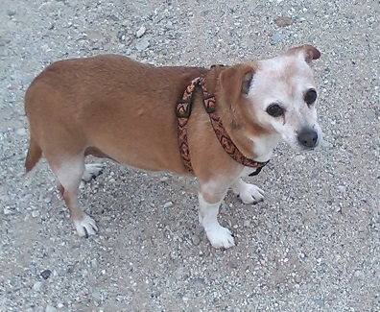 NN

